
Project Title - Customer Purchase Behavior Analysis using Exploratory Data Analytics and Visualization Techniques

Submitted in partial fulfillment of the requirements for the award of the degree of
Master of Computer Applications (MCA)
By

Student Name: Hritik Agarwal
Enrollment No: O24MCA110547
Under the guidance of
Guide/Mentor Name: Anurag Goel

Certificate
Copy to the certificate received from Qollabb to be pasted here.

Declaration
I, Hritik Agarwal, hereby solemnly declare that the project report titled "Customer Purchase Behavior Analysis Using Exploratory Data Analytics and Visualization Techniques" submitted in partial fulfillment of the requirements for the award of the degree of Master of Computer Applications (MCA) is my original work.
I further declare that:
- This project has been carried out by me during the academic year 2025-2026 under the supervision of Anurag Goel (Guide/Mentor Name).
- The work has not been submitted previously to any other university, institution, or examination body for the award of any degree, diploma, or certification.
- All sources of information used in this report have been duly acknowledged and referenced in accordance with academic ethics and plagiarism norms.
- The data presented in this report is authentic to the best of my knowledge and has not been fabricated or manipulated.
- I understand that if any part of this declaration is found to be false, my project may be rejected and disciplinary action may be taken as per institutional rules.
Place: Noida, Utter Pradesh, India
Date: 10ssssssss May 2026
Student Signature: 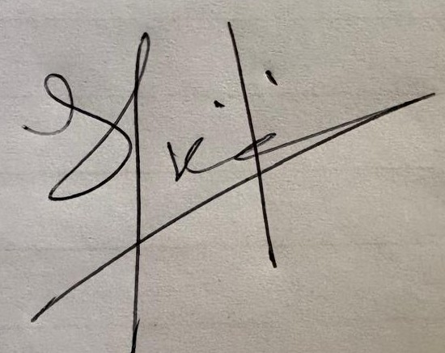
Student Name: Hritik Agarwal
Enrollment No: O24MCA110547

Acknowledgement
Write a short paragraph thanking your guide (Mentor), faculty members and organization, for their support.
I’m grateful to my mentor, Mr. Anurag Goel, for his continuous support and practical guidance while I worked on my MCA final semester project on customer purchase behavior analysis using exploratory data analysis and visualization techniques. His inputs helped me stay focused and improve the quality of my work. I also want to thank my faculty members for their encouragement and helpful feedback throughout the project. Lastly, I appreciate the organization for giving me the opportunity, resources, and environment needed to complete this project successfully.

Abstract / Executive Summary (150–250 words)
- Topic of the study
- Objective
- System Analysis
- System Design
- System Implementation
- Testing
- Future Scope

Table of Contents
Certificate 1
Declaration 2
Acknowledgement 3
Abstract / Executive Summary (150–250 words) 4
Abstract 6
Chapter 1: Introduction 7
Chapter 2: System Study 13
Chapter 3: System Analysis 21
Chapter 4: System Design 29
Chapter 5 : System Implementation 39
5.1 Development Environment 39
5.2 Loading the Dataset 39
5.3 Understanding Columns 40
5.4 Checking Missing Values 41
5.5 Checking Duplicate Data 41
5.6 Cleaning and Standardizing Data 42
5.7 Basic Analysis (Descriptive Statistics) 42
5.8 Product Analysis 42
5.9 Seasonal Analysis 43
5.10 Demographic Analysis 43
5.11 Payment Method Analysis 44
5.12 Feature Engineering 45
5.13 Customer Segmentation 45
5.14 Visualization 46
5.15 Exporting Results 47
5.16 Challenges I Faced 47
5.19 Additional Implementation Understanding 47
Programs 48
Program 1: Load Dataset and Preview 48
Program 2: Display Column Names 49
Program 3: Check Missing Values 49
Program 4: Remove Duplicate Rows 50
Program 5: Normalize Column Names 50
Program 6: Descriptive Statistics 51
Program 7: Top Products Analysis 52
Program 8: Category Distribution 53
Program 9: Gender-wise Spending 54
Program 10: Seasonal Spending Analysis 54
Program 11: Location-wise Sales 55
Program 12: Payment Method Analysis 55
Program 13: Frequency Mapping 56
Program 14: Annual Spend Calculation 57
Program 15: Customer Segmentation 57
Program 16: Age Group Creation 58
Program 17: Bar Chart for Top Items 59
Program 18: Pie Chart for Category Share 59
Program 19: Histogram for Age Distribution 60
Program 20: Export Cleaned Dataset 61
Chapter 6: Testing 62
Extended Testing Explanation 65
Chapter 7: Results & Discussion 68
7.1 Overview of Results 68
7.2 Product and Category Analysis 68
7.3 Seasonal Analysis 68
7.4 Customer Behavior (Frequency) 69
7.5 Demographic Analysis 69
7.6 Payment Method Analysis 70
7.7 Customer Segmentation 70
7.8 Overall Observations 70
7.9 Practical Meaning 71
7.10 Limitations 71
7.11 Final Thoughts 71
Practical Analysis Process Followed 71
Challenges Faced 72
Detailed Interpretation of Key Findings 72
Practical Use of Findings 74
Personal Reflection 74
Chapter 8: Conclusion & Future Scope 78
Observations 78
Learning Outcomes 81
Detailed Limitations of the Project 82
Possible Improvements 82
Practical Use of This Project 83
Personal Experience While Doing This Project 83
Discussion and Overall Learning 83
Final Summary 84
Overall Understanding and Final Reflection 85
Final Learning Summary 86
Closing Thoughts 89
Chapter 9: References 89
Chapter 10: Appendices 90

Abstract
This research explores customer purchasing behavior through exploratory data analysis and visualization approaches using a publicly available dataset on shopping trends with 3,900 individual customer records. The central aim of the project is to explore correlations between demographic factors, product types, geographical locations, payment preferences, and purchase habits on the one hand and consumer behavior on the other hand. This study adheres to a well-defined process, which includes data acquisition, preparation, exploratory analysis, visualization, and interpretation of findings for the benefit of business decision-makers. The chosen dataset is structurally neat in the sense that there are no null entries and duplicates in it. Hence, this project can focus more on its analytical dimension than any data pre-processing activities. New fields such as number of purchases annually, estimated time period between purchases, annual expenditure estimate, and an approximation of the customer lifetime value during three years have been created in the dataset to bring about a business-oriented perspective. In addition to this, the analysis reveals that clothing occupies the highest market share, that autumn purchases involve the highest mean transaction volume, and that frequent shoppers still carry great significance despite small individual basket sizes. Besides this, a rule-based segmentation method has been employed to distinguish premium loyalists, big purchase occasional shoppers, regular budget purchasers, and low engagement clients.

Chapter 1: Introduction
However, in both traditional retail and online e-commerce, customers do not purchase randomly. There is always a certain influence of preference, seasonal demand, affordability, ease of transactions, purchasing experience, and payment methods on each order placed by a particular client. In such circumstances, companies rely on customer data extensively to analyze purchase history, seasonality, and customer loyalty. Therefore, even the simplest exploratory analysis can provide valuable insights for campaign design, goods allocation, packaging, and retention practices.

The current project is dedicated to the exploration and visualization of customer purchase behavior by utilizing exploratory data analytics (EDA). In order not to start the study by constructing predictive machine learning models, it was decided to conduct the comprehensive descriptive study first. This choice suits an academic report as EDA provides us with the understanding of the structure and quality of a dataset, allows us to detect useful patterns, and create business logic.
The chosen dataset is public shopping trends with 3,900 observations at customer level. In the dataset, there are demographic attributes like age and gender, shopping attributes including items purchased, their category, season, payment methods and location, and behavior attributes like number of purchases, previous transactions, and subscription status. All those features provide us with the ability to use the dataset for a college project in terms of descriptive statistics, customer segmentation, feature engineering, visualization, and recommendations.
Problem Statement
Many retail firms gather large amounts of customer and sales data. Nevertheless, just because of collecting data, the company will not get any valuable information. As long as buying patterns remain unclear, the firm will keep conducting the same generic campaigns, stock irrelevant products, or fail to address the needs of potential valuable customers. The issue tackled by the project is how to transform customer shopping dataset into valuable evidence of product demand, seasonality, customer segments, and purchase behavior.
Objectives of the Study
Objective | Output
Data collection | Gather a relevant open retail/e-commerce dataset
Data cleaning and profiling | Check for missing, duplicate and consistent entries
Descriptive exploratory data analysis | Mean, median, counts and distributions
Customer behaviour study profile | Customer demographics items, mode, payment location and seasonality
Feature engineering | Create purchase frequency, total year pending CLV proxy
Visualization histograms | Line craft, pie chart, Dashboard and correlation plot

Scope of the Project
This project will have a well-defined scope to keep focus, clarity, and relevance in our work. First and foremost, the primary aim of the project is the exploratory analysis of the given dataset. In particular, we will explore the dataset in depth and then apply feature engineering methods along with interpretation of results for business value.
This project does not focus on creating a fully functional system but rather on the exploration of the given data, pattern detection, and business decisions on that basis. Therefore, we will concentrate on exploring trends, anomalies, relationships within the dataset, and applying proper analysis methods. Specifically, Exploratory Data Analysis (EDA) will be used extensively in the project. EDA helps to detect patterns within the data and generate hypotheses that can be improved using feature engineering. One aspect of this project scope worth mentioning is the lack of several components that might otherwise be included in an implementation project. To begin with, live transaction processing, data pipelines, and a recommendation engine will not be implemented in the process of this project. Furthermore, the implementation of a web application or dashboard is out of the scope of the project. These components belong to the realm of production-level systems and require additional work on scalability and deployment.
Nevertheless, this project is set up with future improvement opportunities in mind. In other words, the methodology and structure of this project will allow easy transitions to new levels of complexity without losing consistency in previous results. In particular, the results of this analysis can easily become the basis of further predictive modeling projects with machine learning algorithms. Likewise, the processed dataset and generated features can serve as a source for building interactive dashboards in order to make business decisions promptly.
Moreover, this project lays groundwork for a production-level analytics pipeline. The use of clean reproducible workflow allows us to modify the process described to fit in an automated system with regular update of data and visualization. This way, we ensure relevance of our current implementation for real-life cases even though it does not include such features yet. Most student-level data analysis projects end up suffering from "visualizations first." They do not take care of clearly defining the objectives. As a result, they end up having a lot of visualizations without knowing whether they make sense. Most importantly, such an analysis would be descriptive but not meaningful and coherent in its reports/presentation.
Analytic approach
This project employs a more systematic and well-structured analytical approach. Firstly, it takes into account business questions as the most important factor. In other words, all steps of this analysis will be based on "questions first" instead of visualizations first.
Having identified the main questions, the project goes forward to clean the data set. The reality is that a data set is often filled with inconsistencies, errors, missing values, and duplicates. This is why it is very important to pay attention to these issues when working with real data.
Once the data set is cleaned, the analysis goes forward to Exploratory Data Analysis (EDA). In comparison to random chart creation in many data projects, in our case, the EDA process is well-defined. This means that we create visualizations based on the question we want to analyze.
Afterward, we move to feature engineering to derive more advanced features. One should note that creating advanced features is critical for any data analysis project because it makes it more insightful. In our case, it is possible to create more complex attributes through the combination of the existing features or time attributes, for example.
Lastly, we interpret the results of our analysis in business terms. This is another step which makes our data project special and unique compared to others. In other words, after analyzing data, we explain how it can affect our business and provide some useful insights for business owners.
Therefore, following this logic and workflow (questions, cleaning, EDA, feature engineering, business interpretation), we make sure our work becomes coherent and logical. It makes the project stronger in the evaluation process since our analysis is more analytical and business-focused.
Tools used
- Python for data processing in analysis
- Panda and NumPy for data cleaning and feature engineering
- MS Word for reporting preparation
- PowerPoint for final presentation
Importance of Customer Data in Modern Business
- In today’s digital environment, customer data has become one of the most valuable assets for businesses. Earlier, companies mostly depended on traditional methods such as manual surveys or direct customer feedback to understand market behavior. However, with the growth of online shopping and digital payment systems, businesses now generate large amounts of customer-related data every day. This data includes information about customer preferences, spending patterns, product categories, shopping seasons, payment methods, and purchase frequency.
- Because of this, organizations are now focusing more on data-driven decision-making instead of depending only on assumptions. Companies that understand customer behavior properly are usually able to improve their products, customer service, and marketing strategies more effectively. For example, if a business notices that a specific category performs better during a certain season, it can increase inventory and promotions for that period. Similarly, understanding customer spending habits can help businesses design offers and loyalty programs more efficiently.
- One important thing I understood while working on this project is that customer behavior is not always simple. Different customers purchase products for different reasons. Some customers buy products frequently in small amounts, while others purchase occasionally but spend more money at once. Because of this, analyzing customer data becomes very useful for identifying different customer groups and understanding how businesses can serve them better.
- Another reason why customer analytics is becoming more important is competition. In modern markets, companies compete not only on product quality but also on customer experience. Businesses that understand customer needs faster can respond better and improve customer satisfaction. Even small insights from data can help companies make better decisions related to pricing, product availability, and customer engagement.
- This project focuses mainly on understanding these patterns through exploratory data analysis. Instead of directly applying advanced machine learning models, the project first concentrates on understanding the structure and behavior of the dataset. This approach is important because meaningful analysis always starts with understanding the data properly before making predictions or automation systems.
- Role of Exploratory Data Analysis
- Exploratory Data Analysis, commonly known as EDA, plays a very important role in data science projects. While working on this project, I realized that EDA is not only about creating charts. It is more about understanding the dataset carefully and identifying useful patterns.
- EDA helps in answering basic but important questions such as:
- Which product category is most popular?
- Which customers spend more?
- Does season affect purchasing behavior?
- Are there any unusual values or inconsistencies in the dataset?
- These questions may look simple, but they provide a strong foundation for deeper analysis. If these basics are not understood correctly, then advanced analysis may also become unreliable.
- Another thing I noticed is that EDA helps improve confidence in the dataset. Before performing calculations or feature engineering, it is important to understand whether the data is clean and logically structured. In this project, checking missing values, duplicate records, and data consistency helped ensure that the dataset was reliable for further analysis.
- One more important learning from this project is that visualization should support understanding instead of just making the report look attractive. Every chart should provide meaningful information. For example, bar charts helped compare product categories, while histograms made it easier to understand customer age distribution. These visualizations simplified the process of identifying patterns inside the dataset.
- Overall, this project helped me understand that EDA is one of the most important stages in any analytics project because it builds the foundation for all future analysis and interpretation

Chapter 2: System Study
So customer analytics has become a real important part of how modern retail businesses make decision today. Even companies are not using advanced machine learning mod. They still rely on basic description. Elaborator analysis to understand what is going on their businesses. In simple terms they want to figure out things like which product of performing well which seasons bring more sales. What kind of customer spends More and with certain payments of channels are linked with the higher spending.
The main idea here is not allow us to pretending the future instead. It’s more about Ali understanding the present situation business want clarity what works what’s and where that should focus more. For example particular category of a product performs better. The business can prioritise its item. Promote and market in the same way. If certain seasons show higher demand, companies can plan their campaigns inventory accordingly, even simply observation like which customer tends to spend more or by frequently can make bigger difference in decision making.
One of the most useful approaches of the kind of work is EDA which was introduced by John Turkey. The idea behind EDA is quite straightforward before jumping into complex techniques, you should first explore data properly. The self understanding what the data actually looks like and avoid making unnecessary assumptions. In a retail setting, EDA becomes even more useful. It helps in checking how low price are distributor which product category dominates and how customers are making purchases. It can also highlight the issue in data such as duplicate, missing values, unusual entries that might affect the result.
Another important thing to understand is raw data alone is not always very useful for a business point of view. Companies usually prefer simple and meaningful mattress instead of raw data. That’s why analytics convert basic variables 2 into more under stable measures like annual spending purchase vacancy, average basketball value, and customer lifetime value. These mattresses are easier to interrupt and are more useful while making business. That’s it. It also important to honest about the limitations of data set in this project. For example, we don’t have an exact time for every customer transaction because of that some of the calculation matters are only approximate. This does not make analysis wrong, but it does means the result should be interpreted carefully not treated as exact figures.
Another thing that often gets overcooked in project is a purpose of visualisation, a lot of times students create charts just to make the reports look good but reality, every chart should answer specific question. If a chart does not add any real value, it’s better not to included. The data sites used in the project is quite suitable for the college level analysis and includes a good mix of variables like customer, demographic project, choice, location, purchase amount, session, payment methods, buying frequency, all in one place. This make it easier to perform a detailed analysis without needing traditional data sources.
At the same time that data set appears to relate, clean and balance while this helps for learning purpose, it also means we should careful not to take overly claims in real world situation. Data is usually more complex and affected by many external factories, finding this project are based on observation pattern rather than proven, cause and effective relationship.
Review review of similar analytic ideas
We are looking at a similar analytic study. Several common approach can be observed. One of the most common areas of focus is a product analysis. Business of examine which product are selling the most how different categories contributed to overall sales and demand changes over time.
Customer profiling is another widely used techniques. This involves analysing catering such as a gender location and spending behaviour by grouping customers and segments. Business can better understand their targets and design more effective marketing strategy. Value base analysis is also important area instead of treating all customer security business try to identity five high value, customers using mattresses like customer lifetime, value, annual spending and purchase frequency. This help in prioritising the source building long-term relationship with profitable customers.
In addition to the approaches, many modern projects use the dashboard and visual summaries. These tools are designed to present keys instead in simple and clear manner by making it easier for decision makers to understand and act on data
Research gap and motivation
Despite the availability of a various techniques, many student projects tend to stop at a basic analysis. They create chart describes the results but not go further to explain their practical significance. As a result, there is an often gap analysis and the real-world application.
This project came to adjust the gap instead of focusing on and visualisation. It goes step further by creating meaningful variable, discussion, the limits of data and providing practical recommendations. For example, if a certain product category performing well, the analysis suggest that the business should focus more on those categories. Similarly, the customers who purchased even if they’re standing for transaction is low can be valuable in the long run and should be trading according to the data or their purchase history.
Session trends are considered for practical perspectives business. Use these instincts to plan their marketing campaigns, inventory strategies, more effectively by aligning business decisions with a data driven insights. Company can improve their overall performance by listing or by verifying their category, the data of purchase history of sales and customer purchase history as well.
Conclusion
Overall, the main motive behind this project is to improve data analysis and focus on meaningful interpretation. The goal is just not to analyse data but to use it properly in the way of to support out the business and even for a better making decision.
By combining the analysis, feature, engineering and business interpreter. The project create a strong analytical foundation at the same time. It remains realistic about its limitation about data and avoid making claims.
In the end, the value of data analysis lies in the ability to connect numbers with the real-world action. This project attempts to achieve that by running and turning raw data into understandable and useful data
Extended Understanding of Data Analysis and Approach
In this project, data analysis plays a crucial role. At first, I thought data analysis was mainly about using tools and writing code. However, after working on this project, I learned that it involves understanding the data and thinking logically. While tools assist in calculations, the key is how we interpret the results. One of the first things I realized is that it's important to understand the dataset before starting any analysis. If we dive into the data without comprehension, we risk making mistakes. Therefore, I took some time to check the structure of the dataset and grasp the meaning of each column. Another important point is that data analysis is not a one-step process; it consists of multiple connected steps. If any step is done improperly, it can skew the final results. For instance, poorly cleaned data can lead to incorrect analysis outcomes. As I worked with the dataset, I recognized the significance of checking for missing values. Missing values are common in many real-world datasets, and we need to handle them carefully. In this project, there were no missing values, but I still verified that everything was correct. I also made it a point to check for duplicate data. Duplicate entries can confuse analysis, especially when calculating totals or averages. By identifying duplicates, I ensured that the dataset remained accurate and reliable. Understanding the type of data is another critical aspect of data analysis. Some columns contain numerical values while others contain text. This distinction affects how we analyze the data. For example, we can use numerical data for calculations and text data for grouping and categorizing. While working on this project, I realized that asking the right questions is vital. Instead of randomly examining the data, I focused on specific questions, such as which category is performing better or how customers behave. This focus kept me on track and made the analysis more meaningful. Data analysis should proceed step by step. Trying to do everything at once can lead to confusion. Following a proper sequence makes it easier to understand and manage. I found that simple methods can yield valuable insights. Initially, I thought complex techniques were necessary, but I discovered that basic operations like grouping, counting, and filtering are often sufficient for understanding the data. Another essential lesson was verifying the results. Even if the code runs successfully, it’s crucial to check if the output is logical. Sometimes the code may execute without errors, yet still produce incorrect results due to logical flaws. During the analysis, I learned to be cautious with assumptions. Initially, I had certain expectations about the data, but the results sometimes differed. This experience taught me to rely on data checks rather than assumptions. Visualization is also important in data analysis. Charts can simplify understanding compared to raw numbers. In this project, I created straightforward charts to represent the data, which made it easier to spot patterns and trends. However, not all charts are beneficial. Overloading a project with charts can be confusing. Therefore, I focused on creating only those charts that clearly convey important information. I also noticed that working with data needs patience. Results may not be clear immediately, and it can take time to interpret them. Instead of rushing through the process, it’s wiser to spend more time analyzing the data carefully. Throughout this project, I improved my ability to explain results in simple terms. Initially, it was tough to translate technical output into easy-to-understand explanations, but practice made it easier. I learned that data analysis is not just about obtaining results but also about presenting them clearly. If the results are not explained well, they lose their value. Another crucial takeaway is that small steps can lead to significant improvements. Even simple checks like verifying column names or checking values can prevent errors. I recognized that it's okay to make mistakes during analysis. Mistakes can lead to learning and a deeper understanding. Instead of getting overwhelmed, I focused on correcting my errors and learning from them. Overall, this chapter helped me grasp the basic process of data analysis and built my confidence in handling data and performing analysis.
Thoughts on Data Analysis Process
While working on this project, I realized that data analysis is continuous. It doesn't end after getting results; it requires checking, rechecking, and enhancing understanding. An important part of this process is reviewing the data multiple times. When I first examined the data, I understood only the basic details. However, upon further review, I discovered more patterns and relationships. Data analysis demands logical thinking. Blindly following steps doesn't suffice; understanding the purpose of each step is vital. For instance, when grouping data, it’s essential to know what we aim to find. This understanding helps in choosing the right method. I learned that not all results are strong or clear. Some may show only minor differences, yet they are still valuable. Data analysis should be straightforward and clear. Using complicated methods without understanding them can lead to confusion. It's better to stick with methods that can be easily explained. Throughout this project, I recognized the importance of consistency. Each step should follow a clear structure, making the project better organized and easier to grasp. I also realized that data analysis is not purely technical. It involves thinking and interpretation. The same data can be analyzed in various ways, depending on our approach. Another key point is that data must be handled carefully. Even small errors can impact results, so I paid close attention to the details. I found that practice enhances understanding. The more I worked with the data, the more skilled I became. This chapter laid a solid foundation for the rest of the project, making later steps easier to navigate.

Understanding Retail Analytics in Practical Situations
Retail analytics is becoming more important because businesses now deal with very large amounts of customer data. Every customer purchase creates information that can later be used for analysis. This information helps businesses understand customer interests, buying habits, seasonal demand, and overall market behavior.
Earlier, businesses mostly depended on experience and assumptions for making decisions. However, modern businesses are slowly moving toward data-supported decision-making. This change is important because decisions based on actual customer data are usually more reliable than decisions based only on assumptions.
While working on this project, I understood that analytics is not only useful for large companies. Even smaller businesses can benefit from simple analysis. For example, knowing which products are sold most frequently can help in stock management. Similarly, understanding which customers purchase regularly can help businesses create loyalty programs and targeted offers.
Another important thing is that customer behavior changes over time. Trends that are popular in one season may not remain popular in another season. Because of this, businesses need to continuously analyze customer data instead of depending on old observations. This is one reason why retail analytics has become a continuous process rather than a one-time activity. This project also helped me understand that business decisions become easier when data is presented in a simple form. Raw data itself is difficult to understand, especially when the dataset is large. But after organizing the data and creating visualizations, patterns become much easier to identify.
Importance of Data Cleaning and Preparation
One of the most important stages in data analysis is data cleaning. At first, I thought this step would be very simple, but later I realized that cleaning and validating data is extremely important because incorrect data can lead to incorrect conclusions.
Real-world datasets often contain:
- Missing values
- Duplicate records
- Typing errors
- Inconsistent formats
- Unusual entries
If these problems are ignored, then even advanced analysis can produce misleading results. In this project, the dataset was already relatively clean, but I still checked everything carefully because assumptions should never replace verification. Another thing I learned is that data preparation improves the quality of analysis. Small actions like standardizing column names or checking data types make later stages much easier. During this project, I understood that data preparation is not just a technical task. It is actually a very important part of the analytical process.
I also realized that patience is important while working with data. Sometimes small mistakes are difficult to notice immediately. Because of this, I had to review the dataset multiple times before moving ahead with analysis.
Importance of Customer Segmentation
Customer segmentation is another important concept used in this project. Businesses usually have different types of customers, and not every customer behaves in the same way. Some customers purchase regularly, while others shop occasionally. Some customers spend more money, while others prefer low-cost products. Because of these differences, businesses often divide customers into groups based on their behavior. This process is called customer segmentation.
While working on this project, I learned that segmentation helps businesses understand which customers are more valuable in the long term. For example:
- Frequent buyers may generate stable long-term revenue
- High spenders may contribute larger one-time purchases
- Low engagement customers may require additional marketing efforts
Customer segmentation also helps businesses improve marketing efficiency. Instead of showing the same advertisements to everyone, companies can target specific customer groups more effectively. Another thing I noticed is that even simple segmentation methods can provide useful insights. Complex algorithms are not always necessary. Sometimes grouping customers based on purchase frequency and estimated spending is enough to identify important patterns.
Learning Experience During the Study Phase
While completing this chapter, I understood that system study is not only about theoretical concepts. It also involves understanding how analysis works in practical situations. Earlier, I thought data analysis was mainly about coding and calculations. But after working on this project, I realized that understanding the logic behind each step is much more important.
One of the biggest things I learned is that asking proper questions makes analysis more meaningful. If the objective is unclear, then the analysis can easily become confusing. Because of this, I tried to keep the project focused on practical business-related questions instead of creating unnecessary complexity. I also learned that simple methods can still provide strong insights when they are used properly. Initially, I believed that advanced methods were always better, but this project showed me that even basic descriptive analysis can help in understanding customer behavior.
Another important thing I understood is that data analysis requires continuous learning. At the beginning, some parts of the dataset were difficult for me to understand. But after working step by step, things gradually became clearer. This project improved my confidence in handling datasets and interpreting analytical results in a simple manner.

Chapter 3: System Analysis
We will focus on understanding what analytic system is in. This project is expanded to and how it’s operated step-by-step in typical software engineering project. This section usually takes about a system, user workload, technical requirements. However, in this case, the system is not a software application with a user interface but read the data analysis pipeline itself where we will use raw data to define the exact behaviour of the sales customers and products.
In the simple terms, the system here can understood sequence of steps first is to collect data. Then the data would be checked for any errors after that, it is clean and transformed into a usable format. Once the data is ready, different techniques will be applied to generate insights. These insights are in the presented use visualisation and finally documented in the form of report and presentation.
The structure flow ensure that analysis is not random but follows a logic and reputable process. It also makes the work easy to explain review and improve the data in future. For example, we are going to use the data in future to analyse the product sale, market value and the importance of a product like in which season it is going to sale up in which season it is going to sales down and we can determine the product whether to increase the quality of it.
Functional and non-functional requirements
In this project, we are going to see the importance of clearing what the system should do so we have divided the assumptions into two parts function and non-function requirements
So, first of all for the functional requirements, we will try to describe the actual task that the system must perform in the project. The first recommend is to load customer shopping data from open-source platform steps ensure that the data used is accessible and transparent and it should not contain any error any duplication.
Once the data is loaded in the system, we must check the quality of it which will includes the identification of Nall values, duplicate records or any errors in the data sets. Even though the dataset appears to clean, this step is necessary because the data should not never be assumed to be perfect without a verification.
Another key requirement in description statistics that involves calculator measuring such as average count and distribution of the products, which will further relate to the structure of a data like for example, new feels such as annual spending purchase intervals and epoxy for customer lifetime value generated. These data sets will help us to analyse the persons, purchase history, product, purchase history, and it would be a meaningful for a business perspective. Like we can say there would be one more point about visualisation, we can create out the charts to represent the products, category session, customer location, different customer segments and about the purchase history like in which area it is getting very high sale and in which area is getting low sale. These kind of a visualisation charts will help us to represent the proper data sets for a product and even for a customer as well.
now we can focus on non-functional requirement like is the quality and the quantity of a system, and it is also important that the result should be understandable, especially for a decision maker.
Lastly, I would say that the person who is presenting the project should be honest should not provide any false information should not create any claims on the data that are not supported.
Types | Requirement
Function | Load customer shopping data set from open source
Function | Check Null values and duplicate data
Function | Generate descriptive statics and frequency summaries
Function | Create values for an annual spend purchase interval
Function | Build visualisation for projects, category, seasons, location, and segments
Function | Export a written report and presentation slides
Non-function | Results should be easy to understand for a decision makers or a Reviewer
Non-function | Work post should be reproducible by using notebook or a script
Non-function | Should stay honest and avoid unsupportable claims

Study
Before starting any project, it is very important to calculate data from different perspective. In the case, the project has been analysed on a technical operation, economic and academic perspective.
From the technical point of view, the project is highly feasible as its use standard python libraries such as pandas and numpy which are basically widely used for data analysis, these data sites are also rated size, which mean it can be processed easily without requiring hardware or complex infrastructure
In this project, the entire workflow can be executed on a regular laptop without any performance issue. Additionally, this step involves in the analysis as simple in a to explain clearly in the classroom or by settings. So this make this project very easy to demonstrate or very easy to explain
Aspects | Status | Remark
Technical feasibility | High | The analysis used standard python libraries, and medium size CSV files
Operation feasibility | High | The workflow can be executed on normal laptop and explain easily in class
Economic feasibility | High | The project use free and open tools and public data sets so implementation cost is minimal

Data understanding
So now the parts start for a data understanding like to understand the data set which is a crucial step in any data analysis project. In this case, the raw data consist of approx 3900 rows and original 18 columns after performing feature engineering and editing variables, the working data expands to 25 columns. The data set does not contain any missing values or delicate true, which is a positive expect to reduce the risk of error during the pre-processing stage and make the analysis smoother. However, even the data appears clean. It’s still important to validate it clearly like it should not be duplicate or should not contain any kind of error, so we have to check it manually.
During the validation process of perform to ensure that all the values are within expected range and there should not be any unusual value or unto Rise field for unexpected entries. The data set includes a variety of reusable variables such as customer demographics, product categories, purchase amount, session, information, payment methods, which allows for a more comprehensive analysis as a multiple expect of customer behaviour can be study together
We can say there would be another important point that has to be noted. While the data site is clean and structured. It may not fully represent a real-world complexity in practical data data often contains more noise. External influences, therefore, the inside is driven from these data sets should be interpreted as a pattern rather than absolute conclusion
Analytical questions
To guide the analysis, we can set a key of questions that has been defined. The questions can help us to maintain the focus and ensure that the analysis should remain relevant.
First question can be like we can focus on identifying which products and categories appears most frequently. This can help us to understand customer preferences and determining which items are highly demandable. Another question can be that whether the average percentage amount changes across different seasons can reuse seasonal trends and can help the business plan to prepare accordingly. Show the project which we are preparing, can also examine whether the customer demographic such as a age or location should show meaningful difference in spending behavior. This can help us to identify the target and design the product more effectively.
We can say the additional question or most important question can be the location as well or the payments methods that are associated with the highest purchase value can also provide the data for a regional train and a customer preference. Finally, we can show the project that how the customer can be group based on the purchase vacancy, so it will help us to identify different customer segments such as high value, customers, buyers, occasional shoppers.
Data Flow Understanding in the Analytical System
While working on this project, I realized that understanding the flow of data is very important in any analytical system. At first, the dataset appears as a collection of rows and columns, but after performing analysis step by step, it becomes easier to understand how raw information is converted into meaningful output.

In this project, the flow starts with collecting and loading the dataset into the working environment. After that, the data is checked carefully for quality issues such as missing values, duplicate records, or incorrect formats. This stage is necessary because even small errors can affect the reliability of the final results. Once the dataset is validated, the next step involves organizing the information into a more usable structure. During this stage, grouping, filtering, and transformation methods are applied so that the dataset becomes easier to analyze. I noticed that proper organization of data also makes coding easier and reduces confusion during later stages of the project.
Another important part of the analytical flow is feature creation. Instead of depending only on original columns, additional fields are generated to improve understanding of customer behavior. Features such as annual spending estimates and purchase frequency provide a more practical business perspective compared to raw values alone.
Visualization is another stage where the data flow becomes more meaningful. Charts and graphs simplify the process of identifying patterns because visual outputs are easier to understand compared to large numerical tables. However, I also realized that visualizations should be connected with clear analytical questions; otherwise, they may not provide useful information. One thing I understood during this process is that every stage in the analytical workflow is connected. If one step is performed incorrectly, the next stages can also become unreliable. Because of this, I tried to maintain a proper sequence throughout the project.
Overall, understanding the movement of data from input to interpretation helped me understand how analytical systems work in practical situations instead of only theoretical concepts.
System Approach and Understanding
In this project, system analysis means more than just a traditional software system. It refers to the entire process of handling and analyzing data step by step. At first, I found it confusing to think of data analysis as a system. However, as I worked through the project, I realized that each step is connected and relies on the previous one. One important thing I recognized is that every step in the process has a purpose. For instance, data loading involves more than just opening the file. It ensures the dataset is in the correct format. Checking the data is not just a formality; it’s a crucial step to confirm everything is correct before moving ahead. I also learned that system analysis helps in organizing work effectively. Without a structured approach, managing the project becomes challenging. By breaking the work into smaller steps, it is easier to understand and execute.
While working on this project, I noticed that each stage depends on the previous one. A mistake in an earlier step can affect later results. For example, if the data is not cleaned properly, the analysis will not be accurate. Because of this, I paid extra attention to the initial steps. Another important point is that system analysis reduces confusion. When the process is clearly defined, it is easier to know what to do next. This clarity also saves time since there is less need to go back and fix mistakes.nI realized that system analysis isn’t just about following steps, but also understanding why those steps are necessary. For example, checking for duplicates is essential because duplicate data can skew the results. Likewise, converting values into the correct format aids in performing calculations.
During the project, I aimed to follow a step-by-step approach. This kept me organized and helped me avoid mistakes. Whenever I skipped a step or hurried through it, I encountered confusion later. This emphasized the importance of following the process carefully. I also learned that system analysis improves the quality of work. When each step is done carefully, the final output is more accurate and trustworthy. This also makes it easier to explain the work to others. I observed that system analysis helps identify errors early. If a mistake occurs in the initial stage, it can be corrected easily. But finding a mistake later makes it harder to fix. Because of this, I made sure to verify each step before moving on.
Another key point is that system analysis helps understand the overall flow of the project. Rather than viewing each step in isolation, it shows how everything connects. This creates a clearer understanding of the entire process. While working on this project, I learned that system analysis requires patience. It can't be rushed; careful checking is vital. Taking the time to understand each step enhances the overall result. I also noticed that system analysis structures the work better. This is beneficial not just for completing the project but also for explaining it later. When the work is organized, presenting it becomes simpler.
I realized that even though the project focuses on data analysis, the concept of system analysis still applies. The steps may differ from a traditional system, but the idea of following a structured process remains unchanged.
Overall, this part of the project taught me how to approach problems systematically. It also enhanced my ability to plan and execute tasks in a logical order.
Final conclusion for the chapter 3
So, in final we can define analytical system in a clear and structure way, it can explain how a data flows from a different stage like from my input to a final output, it can also highlight the requirements and the question that guide the analysis. This project also ensures that analysis is not a random but follows a logical and well-organized approach, which may result in more accurate, more reliable and easier to understand data for a decision making.
So in last when I was working on this chapter, I understood that system analysis in this project is not like a normal software system. Here, the system is more about the flow of data and how each step connects with the next one. At first, it felt a bit confusing to think of data analysis as a system. But when I broke it into steps like data loading, checking, cleaning, and analysis, it became much clearer. Each step depends on the previous one, so it is important to do everything properly.
One thing I noticed is that if the data is not checked properly at the start, then the results later can be wrong. Because of that, I paid more attention to validation steps like checking null values and duplicates. Another important thing I realized is that asking the right questions makes the analysis easier. Instead of randomly checking data, I tried to focus on questions like which category is performing better or how customers behave.
This approach helped me stay focused and not get confused during the process.
Chapter 4: System Design
So finally, we come to the point of system design This project is based on a simple and easy to follow up analytics pipeline. Instead of making the process complicated. The design or the idea is to keep everything clear and transparent. So the approach is that it should help to understand how data moves from its raw stage to a final form inside a report
Now we can overlook the workflow project that follows a simple structure which starts with loading the data set following by the checking and the cleaning of data and after that, we will see how new variables are created to improve the data analysis and then visual charts are generated to identify patron and finally the insight are summarized and present in in a form of reports and slide.
Blue are the step-by-step flow insurance that the analysis is not only correct, but also easy to understand and reproduce
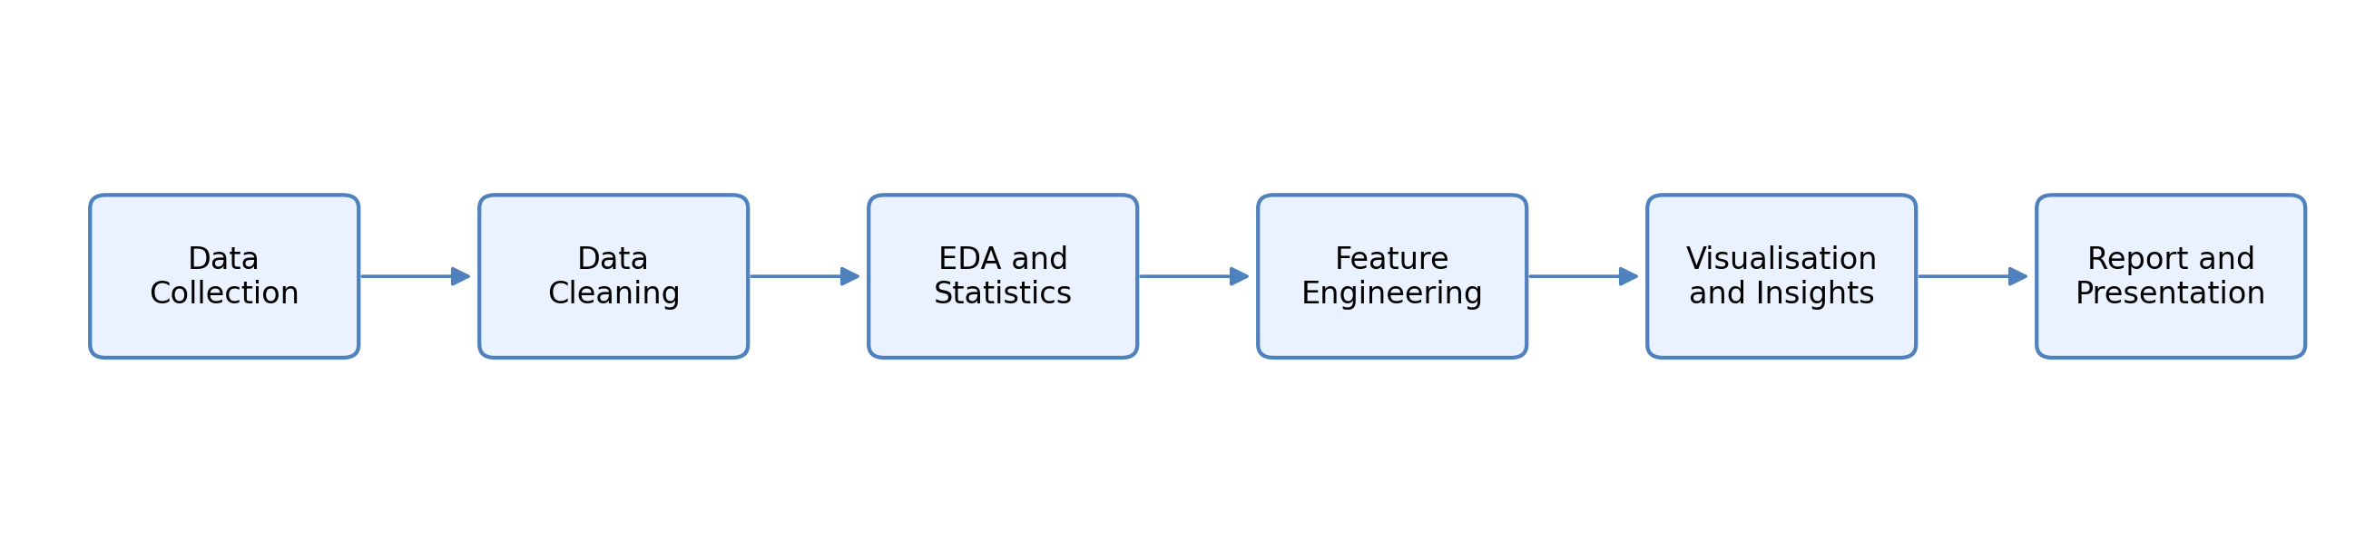
Data set schema used for analysis
Before performing any analysis, it is very important to understand the structure of data set that we are going to use in the project which contains several fields that describes a customer behavior, product, choice and transactions details
The first field which we can start with is a customer ID, which can act as a unique identify for each customer, which can help us to distinguish one customer from another and is useful for grouping and aggregating data. Second point, we can mention that like we can use a data set that includes demographic values such as age gender, which will help us to understand customer profiles and allowed to do comparison between different demographic groups. For example, we can take as spending pattern that can analyzed on the basis of age group or a gender category
We can also use the product related information which is captured through a feel like item, purchase, and category of an item, which will help us further to verify the customer preference and identify which product or are more popular. So now the payment comes like the payment amount should be in rupees or should be in dollars that represent how much a customer spend on a particle purchase, which will help us to verify or like to mark the important variables in the data set, which can relate directly to our revenue and a customer value.
Now the points come to a geographical location through which we can find the feel like through which we can identify the sales of a product at which location which product is high in sales or which product is not in sale. We can also identify areas for higher and lower pending.
Most important thing is for customer feedback which will reflect the review rating field by we can focus the same customer feedback to make the product more popular in that area which have high demand for it.
The act which we are going to use will also include a behavioral indicator such as subscription status, which will show whether a customer is a member of subscriber. This can also be useful when we can while comparing spending between subscribers and non-customers.
Field | Purpose in analysis
Customer ID | Unique customer Identifier
Age and gender | Customer demographic profile
Item purchased and category | Product preferences indicators
Purchased amount | Observed spend value for the record purchase
Location | State wise
Season | Time related seasonal Context
Review rating | Post purchase opinion indicator
Subscription status | Customer membership/subscription flag
Payment method | Preferred payment mode
Frequency of purchase | Declared buying
Previous purchase | Simple loyalty/history signal

Engineered features
We can create an original data site that can provide as useful for information. Additional features where we can create and make the analysis more meaningful.
So, the first feature which can we create is a purchase per year since the original data contains purchase frequency in the data format or data set, we can convert it into a numerical value which can later represent the number of purchases per year and which will make it easier to perform and calculates and make us very helpful to do the comparison between previous year and the current year.
And another feature we can add is estimate purchase interval days. So there is a point like we can do a variable approximate that can define the time that between the purchased based on the frequencies information that that measures and provide a useful indication of a customer buy history
We can also add some advance feature like estimate, annual spend or estimate customer total spent in three years. First of all, we will talk about estimate annual spent which is a feature by which we can calculate by multiplying the purchase amount with the number of purchases per year, this can give us the estimate value that how much a customer can have or can spend annual. Now we can come to the point for that estimate customer purchase a total spend in three years which will help us to represent the lifetime value of a customer by this weekend adjust the previous purchase behaviour and the subscription status to make more realistic like like how much a customer is valuable to us or how much customer is this care about our product.
Now we can mention some points or some features related to a segment like a customer segment and a value segment. In customer segment. We can divide the group of a customers based upon their spendings purchase history, which will help us to identify the high value customer or a loyal customer. In a value segment. We can estimate the total purchase history of a customer spends on a product or on our store, which will allow us to create a simple or easier version to interact a customer, and then we can compare it to a different value set.
Features | Reason for creation
Purchase per year | Convert text to purchase frequency into numerical annual count
Estimate purchase interval days | Approximate time, gaps between purchase from Cadence field
Estimate annual spend | Purchase amount * purchase per year
Estimate customer spend in three years | Three years customer value proxy adjust by previous purchase and subscription status
Customer segment | Rule base segment, combining o and purchase frequency
Value segment | Quartile based CLV group
Age group | Banding variables used for demographic comparison

Visual design plan
Visualization is also an imported rule in presenting a customer clearly or a product data. Clearly. In this project, we are going to use a different type of a charge that are based on a different type of dataset. Like bar chart, which can be used for a comparison for a top product, location, payment methods segments, which will help us to understand the effectiveness of a product in a different group in a different age of peoples.
We would be using your pie chart as well to represent different category share since the number of categories as limited pie chart can work well and provide a quick overview of a data Do some different charts, we can also use line charts, heat maps like in line charts, we can analyses the trends such as seasonal spending changes in spending based on purchase frequency like in heat map, we can compare two variables at the same time like in different categories and sessions, they can identify the pattern that may not be visible in a simple charts.
We can also use histograms that can also show distribution such as age or a customer lifetime value that can help us by understanding how values are separated whether they data is skewed.
Visual | Used for | Reason
Bar chart | Top items, locations, payment methods, and segment | Best for comparison across categories
Pie chart | Category share | Useful, because the number of categories is small
Line chart | Seasonal average spend an annual spent by frequency | Good for ordered category
Heat map | Category vs season average spend | Show two-dimensional pattern clearly

SECTION 1
Workflow Structure and Design Logic
One important part of system design in this project is maintaining a clear workflow structure. Instead of performing analysis randomly, the entire process was organized into connected stages. This helped in reducing confusion and improving the overall readability of the work.
The workflow begins with loading the dataset and validating its structure. After that, preprocessing steps such as checking missing values and duplicate records are performed. Once the data becomes reliable, analytical methods and feature engineering techniques are applied.
I also noticed that designing the workflow in smaller sections makes implementation easier later. Each stage has a specific purpose, which improves both organization and understanding of the project.
Another useful thing about structured design is that it makes the project reproducible. If someone wants to perform the same analysis again, the workflow can be followed step by step without major confusion.
SECTION 2
Importance of Structured Dataset Design
During this project, I understood that dataset structure plays a very important role in analysis. If the dataset is not properly organized, then calculations, grouping, and visualizations become difficult to perform.
The dataset used in this project contains a balanced mix of categorical and numerical fields. Numerical columns such as purchase amount and age are useful for calculations, while categorical columns such as season, category, and payment method are useful for grouping and comparison.
One thing I noticed is that understanding the relationship between columns helps improve analysis quality. For example, combining purchase frequency with spending amount gives a better understanding of customer value compared to using only one variable.
I also realized that properly structured datasets reduce the possibility of errors during implementation. Clear column naming and organized formatting make the analytical process smoother and easier to manage.
SECTION 3
Design Considerations for Visualization
While designing visual outputs for this project, I focused more on clarity rather than decoration. Initially, I thought adding more charts would make the report stronger, but later I realized that too many visualizations can make the analysis confusing.
Because of this, I selected only those charts that support important analytical questions. Bar charts were mainly useful for comparing categories and locations, while histograms helped in understanding numerical distributions such as age and spending values.
Another important design consideration was chart readability. I tried to keep labels, titles, and chart structures simple so that the output can be understood easily without technical difficulty.
I also learned that visualizations should support interpretation rather than replace it. A chart alone cannot explain the entire meaning unless it is connected with proper discussion and understanding.
SECTION 4
Design Perspective of Feature Engineering
Feature engineering was one of the most important design components in this project because the original dataset alone could not provide all business-related insights directly.
During this process, additional variables were designed using existing fields. For example, purchase frequency was converted into numerical form so that yearly spending estimates could be calculated more easily. I also designed customer segmentation fields to simplify comparison between different customer groups. This approach made the dataset more useful for understanding customer purchasing behavior.
Another thing I realized is that feature engineering should remain simple and practical. Creating too many unnecessary features can increase complexity without improving the quality of analysis. Therefore, only those engineered features were included which directly supported the objectives of the project.
SECTION 5
Practical Understanding Gained During System Design
While working on system design, I understood that designing an analytical workflow requires both planning and logical thinking. At first, I thought design mainly refers to diagrams or structures, but during this project, I realized that it also includes organizing how the analysis will move from one stage to another.
One important learning experience for me was understanding how each design decision affects later implementation. For example, if features are not planned properly at the design stage, then implementation becomes more difficult later.
I also noticed that keeping the design simple improves the overall quality of the project. Complicated structures may look impressive, but simple and clear workflows are easier to explain and understand. Another thing I learned is that system design should always support the objectives of the project. Every design choice should have a practical purpose instead of being added only to increase complexity.
Overall, this stage helped me improve my understanding of planning analytical workflows in a structured and organized manner.
SECTION 6
Data Organization Strategy
During the design stage of this project, one important area was organizing the dataset properly before analysis. At first, the dataset looked simple, but after examining it carefully, I realized that proper organization makes analytical tasks easier and more manageable.
The dataset contains multiple types of information such as customer demographics, purchase details, locations, seasonal information, payment methods, and review ratings. Because of this variety, it was necessary to arrange the data in a structured way so that different variables could be accessed easily during implementation. One thing I noticed is that organized data improves both readability and workflow efficiency. For example, when columns are clearly structured and grouped properly, filtering and aggregation operations become easier to perform. This reduces confusion during coding and minimizes the chances of mistakes.
Another important part of data organization was handling categorical and numerical fields separately. Numerical values were mainly useful for calculations and statistical summaries, while categorical values were useful for comparison, grouping, and visualization purposes.
I also realized that maintaining a consistent structure throughout the dataset helps improve the quality of visual outputs. If values are not organized properly, charts and grouped summaries can become inaccurate or difficult to understand. From a design perspective, proper organization also supports future scalability. Even though this project focuses mainly on exploratory analysis, a well-structured dataset can later be extended for predictive analysis, dashboard development, or machine learning applications.
Overall, this stage helped me understand that data organization is not just a technical activity. It is an important design decision that directly affects the quality and clarity of the overall analysis.
SECTION 7
Design Planning for Analytical Accuracy
Another important aspect of system design in this project was maintaining analytical accuracy throughout the workflow. While planning the analysis structure, I understood that every stage should be designed carefully to avoid misleading outputs.
At first, I assumed that accuracy mainly depends on calculations. However, while working on the project, I realized that accuracy also depends on how the data is prepared, grouped, and interpreted. Even small inconsistencies during preprocessing can affect later stages of analysis. Because of this, I tried to design the workflow in a step-by-step sequence where validation was performed regularly. Before applying calculations or generating charts, the dataset was reviewed carefully to ensure that the values were logically correct.
Another thing I learned is that analytical accuracy is closely connected with simplicity. Complicated workflows may increase confusion and make errors difficult to identify. Therefore, I tried to keep the design structure clear and manageable instead of adding unnecessary complexity. I also focused on keeping the engineered features realistic. Since the dataset does not contain exact transaction timestamps, some values such as annual spending and customer lifetime estimates were treated as approximations instead of exact business figures. This helped maintain honesty in the analytical process.
One important observation during the design phase was that interpretation should always remain connected with the actual dataset. Sometimes analysis can become misleading when assumptions are made without proper validation. Because of this, I tried to rely more on observed patterns instead of unsupported conclusions.
Overall, this part of the design process helped me understand the importance of planning analytical workflows carefully so that the final results remain both understandable and reliable.
Design notes on limitations
It will be a very important to consider the limitations of a data set, key limitation, data set represent a snapshot of a customer behaviour rather than a detailed transaction history since exact time of transactions are not available certain features such as purchase intervals and customer life value are estimated rather than calculating them precisely. So by making this distinction is very important in both lethal and academical way that ensures the analysis should remain honest does not create a false impression of accuracy
Even with these limitations, the analysis still provides useful insights. However, the results should be interpreted as a approximate indicator rather than exact value. For example, we cannot provide exact data of a product like every product. History cannot be registered and every transaction history cannot be resisted as some transactions are made physically and some are made online.

Final conclusion of a chapter 4 will be: -
Like this system design, only focus on clarity and transparency. Each step which will be using in the workflow is clearly defined and which will make it easy to understand how analysis is performed and the combine structured data engineered features and well-chosen visualization ensure that the results are meaningful and easy to understand.

Chapter 5 : System Implementation
In this chapter, I will explain how I actually carried out the project step by step. Earlier chapters were more about planning and understanding, but here the focus is on what I really did during the analysis. While working on this part, I realized that implementation is not just about writing code. It is more about understanding the data properly and making sure each step is correct. Even a small mistake at the beginning can affect the final result, so I tried to go slowly and verify everything.

5.1 Development Environment
For this project, I used Python because it is simple and very useful for data analysis. I worked mainly on Google Colab since it is easy to use and does not require installation.
The main tools I used were:
- Python 3
- Pandas (for handling data)
- NumPy (for calculations)
- Matplotlib (for charts)
At first, I was not fully confident with all the libraries, but while working on the project, I became more comfortable using them.

5.2 Loading the Dataset
The first thing I did was to load the dataset into the notebook.
At this stage, I just wanted to make sure:
- The file loads correctly
- No error comes
- Data is visible properly
After loading, I printed the first few rows. This helped me understand what kind of data I am working with. To be honest, this step looked simple, but it was important because if something goes wrong here, everything later would also be wrong.

5.3 Understanding Columns
Next, I checked all the column names in the dataset.
I did this because:
- I needed to know what each column represents
- Some column names can be confusing
- It helps in writing code later
While checking, I noticed that the dataset contains useful information like age, product category, purchase amount, location, and payment method.
This step gave me a clear idea of what analysis I can do.
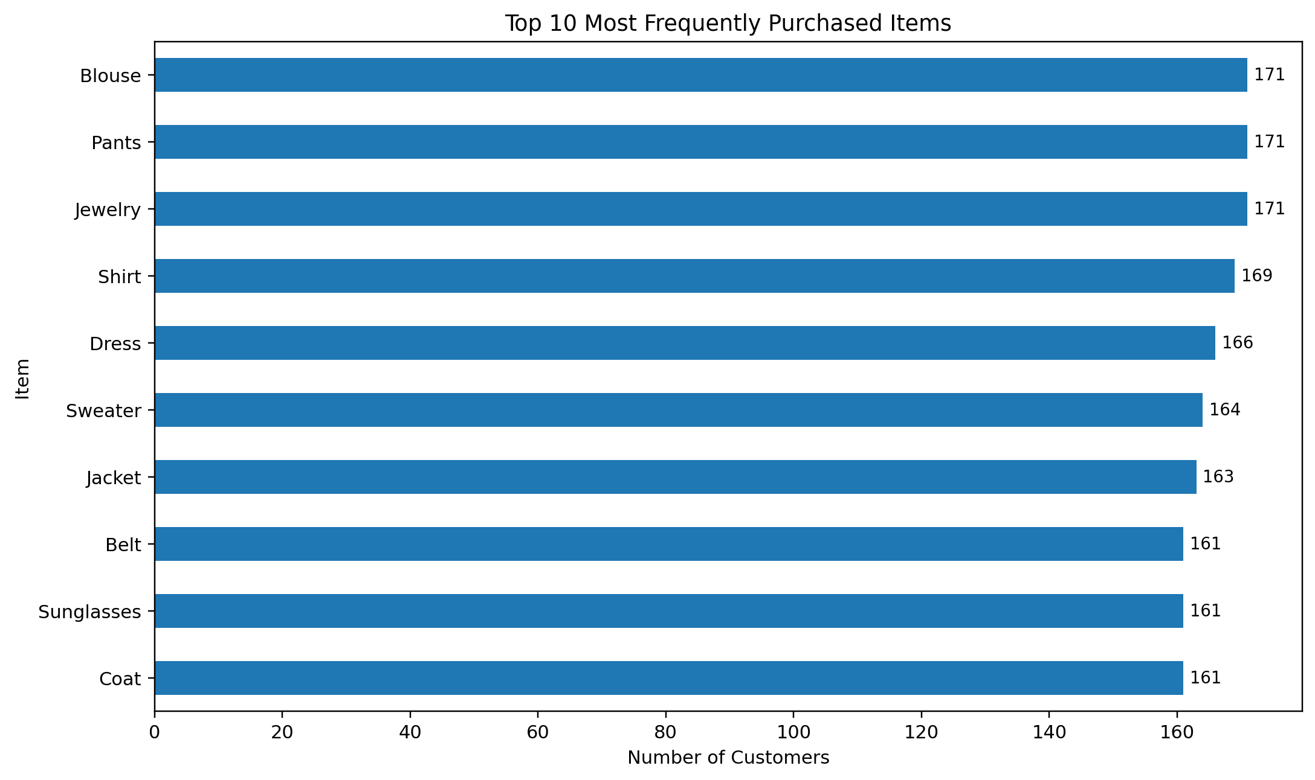

5.4 Checking Missing Values
After that, I checked if there were any missing values. In many real datasets, missing values are common, so I expected some issues here. But surprisingly, this dataset did not have any missing values. Still, I did not just assume it is perfect. I checked all columns carefully because sometimes errors are hidden.
This step made the process easier since I did not have to do extra cleaning.

5.5 Checking Duplicate Data
Then I checked for duplicate rows.
Duplicate data can create problems like:
- Wrong totals
- Incorrect averages
In this dataset, I did not find any duplicates. That was a good thing because it means the dataset is already clean.

5.6 Cleaning and Standardizing Data
Even though the dataset was clean, I still did some basic cleaning.
For example:
- Removed extra spaces
- Standardized column names
I did this because small issues can create errors later during grouping or filtering. While doing this, I understood that even simple cleaning steps are important.

5.7 Basic Analysis (Descriptive Statistics)
Next, I calculated some basic statistics like:
- Average purchase amount
- Median value
This helped me understand the general behavior of customers. From this step, I got a rough idea about how much customers usually spend.

5.8 Product Analysis
In this stage, product-related columns were analyzed to understand how product information is distributed inside the dataset. The analysis mainly focused on grouping product names and categories using frequency-based methods. I used counting operations to identify how many times different products appear in the dataset. Grouping functions were also applied to organize products category-wise. This made the dataset easier to analyze and helped in generating later visualizations. During this process, I understood how categorical data can be handled using simple aggregation methods. It also helped me become more familiar with sorting and filtering operations in Python.

This stage was mainly useful for preparing structured product-related outputs that were later used in charts and result interpretation.

5.9 Seasonal Analysis
After that, I looked at seasonal trends. For seasonal analysis, the dataset was grouped according to seasonal values available in the records. Average purchase-related calculations were performed for each season separately. Before generating outputs, I checked whether seasonal labels were properly arranged because incorrect ordering can affect charts and summaries. Grouping functions and average calculations were used to organize the data. This step helped me understand how grouped calculations are performed on categorical variables. It also improved my understanding of handling ordered data during analysis.

The generated seasonal summaries were later used for visualization and comparison purposes in the project.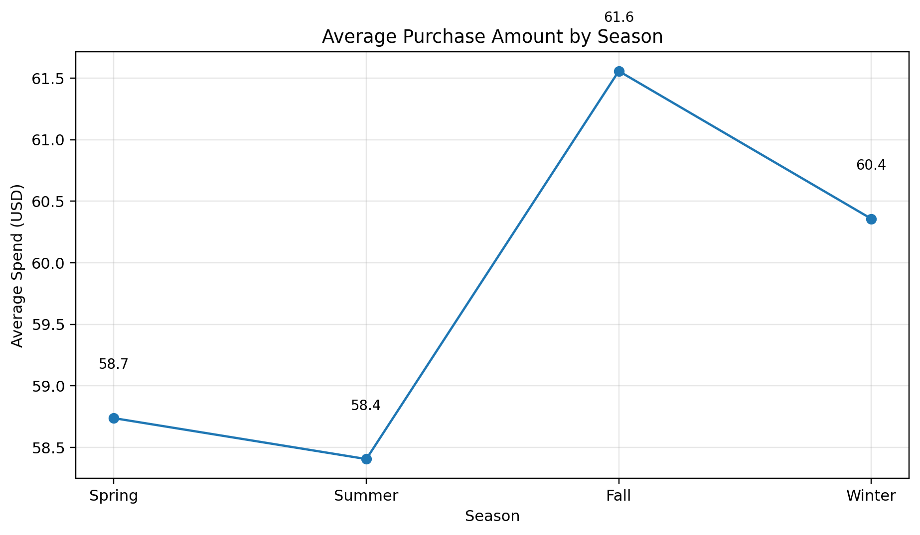

5.10 Demographic Analysis
In this part of the implementation, demographic fields such as age, gender, and location were used for grouped analysis. The purpose of this step was to organize customer records according to demographic categories. Basic grouping operations and average calculations were applied to compare different customer groups. I also created age ranges to make the comparison process simpler and more structured. At first, handling grouped demographic data felt slightly confusing, but after practicing the operations step by step, it became easier to understand. This section mainly helped in preparing organized demographic summaries which were later useful during visualization and interpretation stages.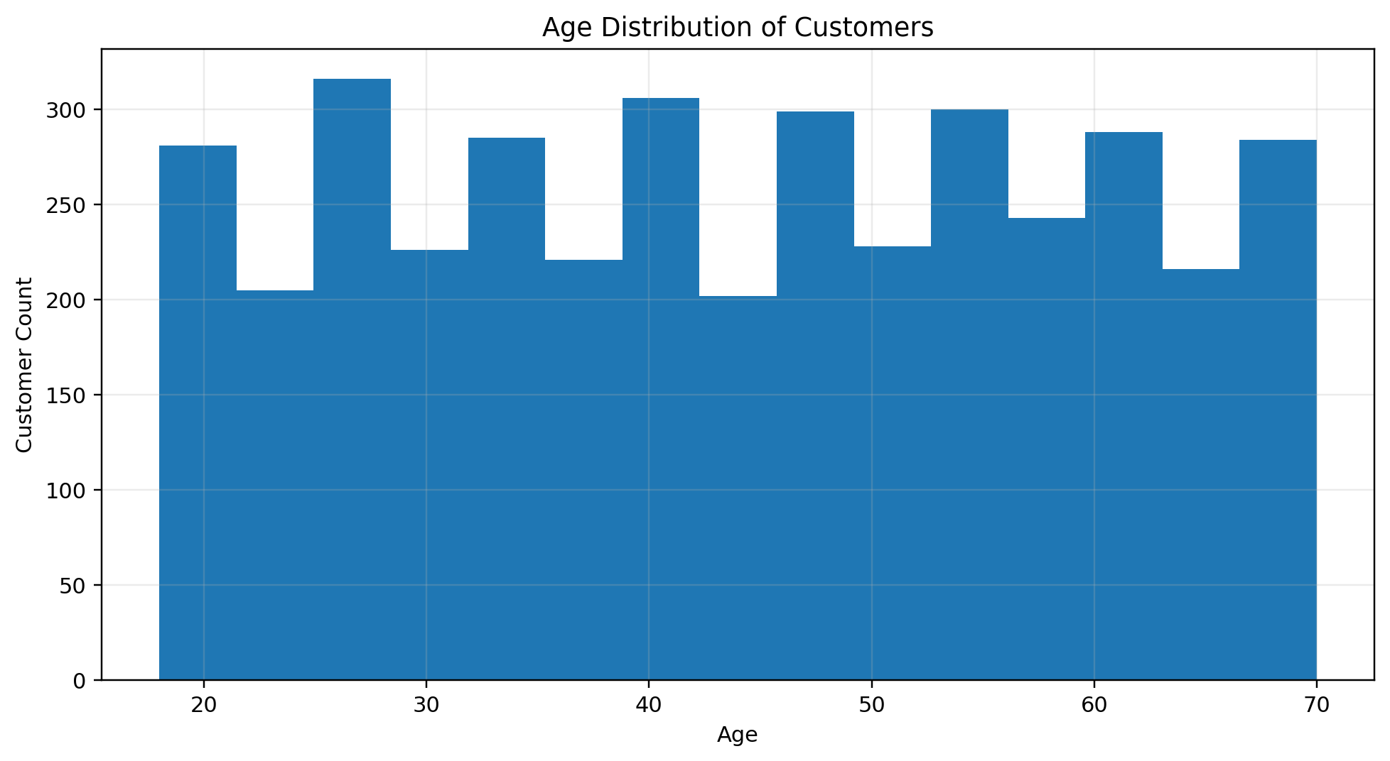

5.11 Payment Method Analysis
The payment method field was analyzed by grouping transaction values according to different payment options available in the dataset. During this process, aggregation methods were applied to calculate average purchase amounts for each payment type. This step helped in understanding how transaction-related categorical variables can be compared using grouped calculations. I also verified that all payment labels were correctly recognized before generating summaries. This reduced the possibility of incorrect grouping during analysis.

The outputs generated in this section were later used as supporting information for charts and comparison tables.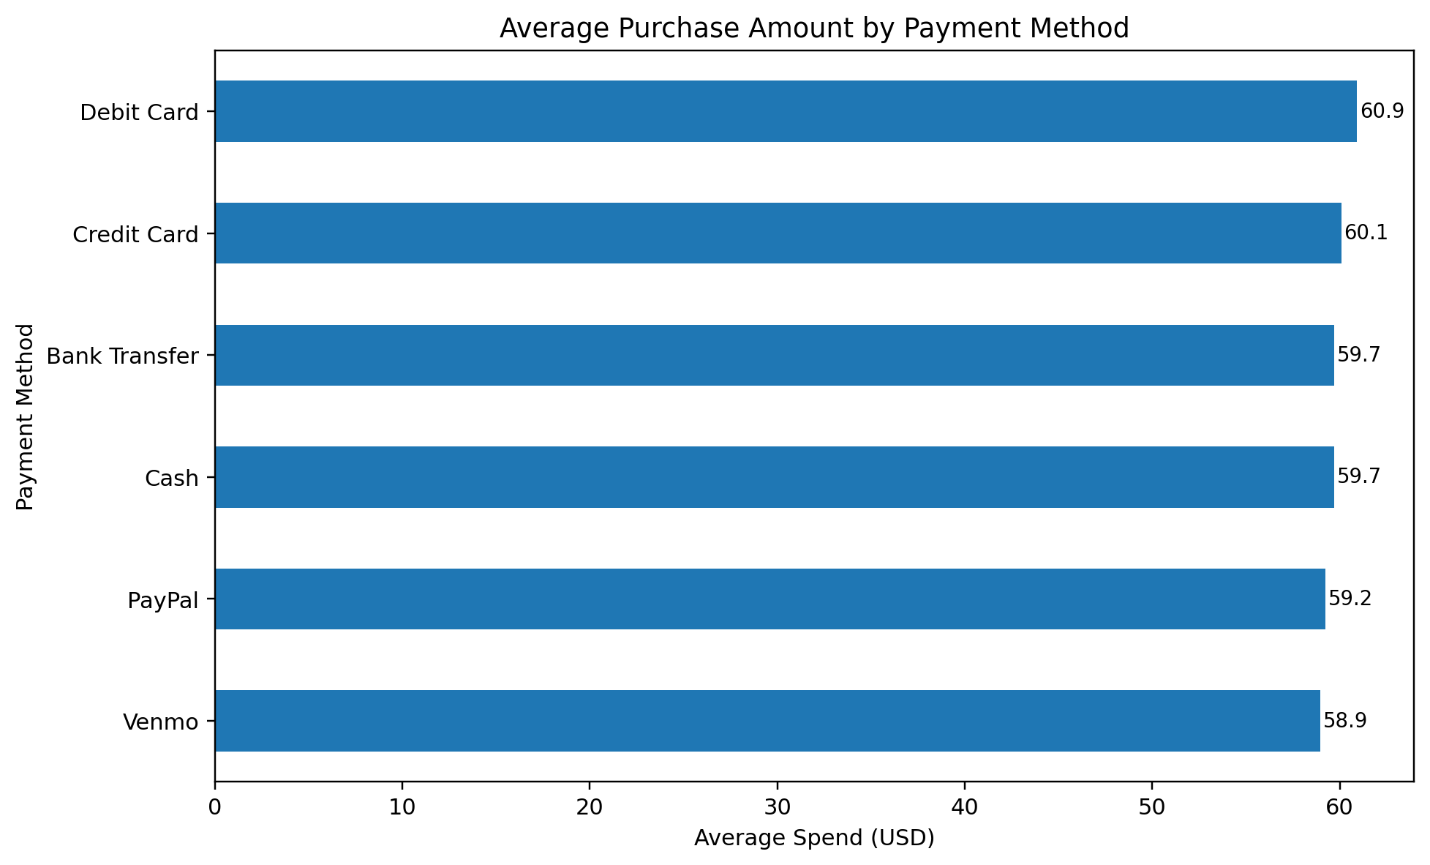

5.12 Feature Engineering
This was one of the most interesting parts for me.
Here I created new features like:
- Purchase frequency (converted into numbers)
- Annual spend estimate
- Customer value (approximation)
At first, this looked a bit confusing, but once I understood it, I realized how useful it is. This step made the dataset more meaningful.

5.13 Customer Segmentation
In this stage, segmentation logic was implemented by creating simple customer groups based on spending-related conditions. Conditional statements were used to divide records into multiple categories such as high, medium, and low segments. This approach helped organize customer data into manageable groups for further comparison.

At first, defining segment boundaries was slightly difficult because the ranges needed to remain simple and understandable. After testing different values, a basic rule-based structure was finalized. This implementation step helped me understand how classification logic can be applied using conditional operations in Python.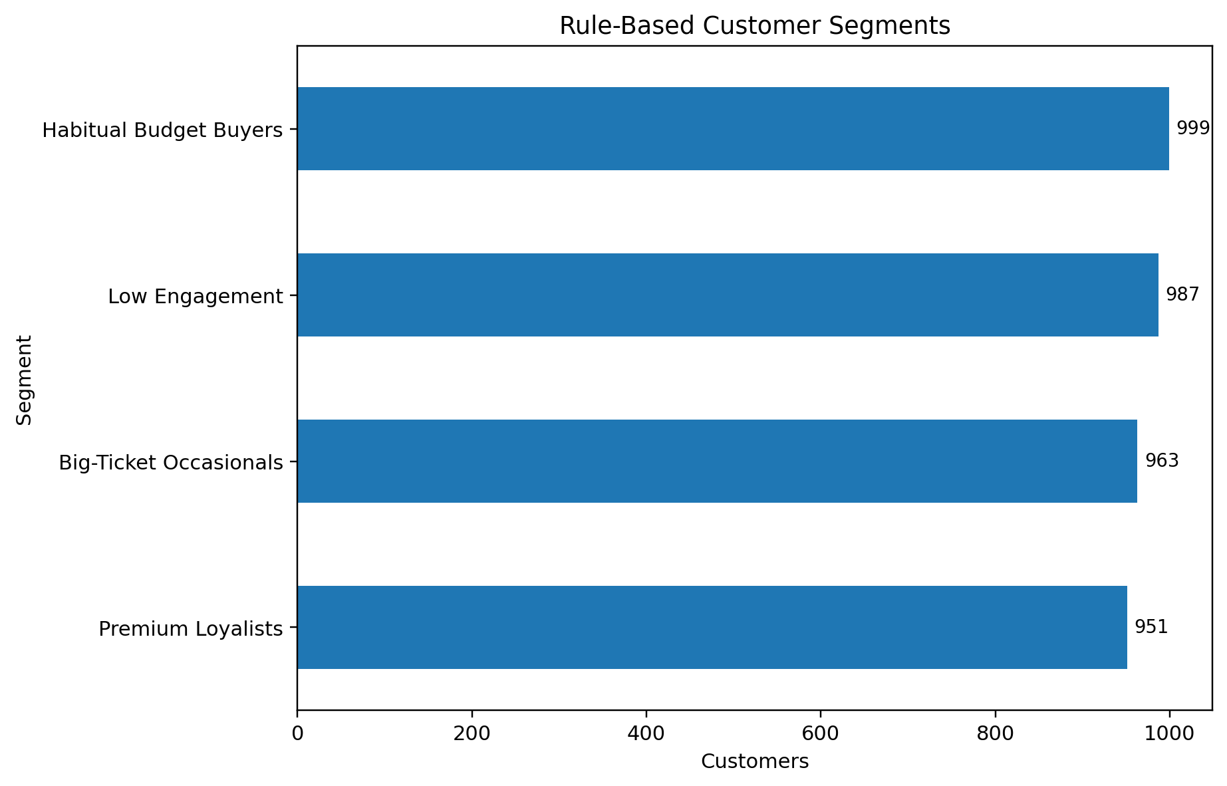

5.14 Visualization
Then I created charts like:
- Bar charts
- Pie charts
- Histograms
While making charts, I tried to keep them simple.
I avoided adding too many charts because I learned that:
A chart should answer a question, not just look good.

5.15 Exporting Results
At the end, I saved:
- Clean dataset
- Charts
- Output files
This step is useful because the work can be reused later.

5.16 Challenges I Faced
While doing this project, I faced some challenges:
- Understanding some columns at the start
- Converting text data into numbers
- Deciding which chart to use
- Interpreting results correctly
These challenges actually helped me learn more.

5.19 Additional Implementation Understanding
While working on the implementation part of this project, I understood that this stage is not only about writing code but also about thinking carefully about each step. At the beginning, I thought that once the code runs without errors, the work is complete. But later I realized that even if the code runs, it is still important to check whether the results actually make sense. At a time of creating new features like purchase frequency and annual spending, I found that these steps were slightly challenging at first. I had to think about how to convert text-based values into numbers. But after trying and testing, I understood the logic behind it. This was one of the parts where I learned something new. I also realized that not every step needs to be complex. Some of the most useful results came from very simple operations like grouping and counting. This helped me understand that data analysis is more about understanding the data rather than using complicated methods.
Another thing I learned during implementation is the importance of keeping the process simple. If too many steps are added without clear purpose, it becomes difficult to understand later. So I tried to keep my work clear and organized. While working on charts, I made sure that each chart has a purpose. Initially, I created some extra charts, but later I removed them because they were not adding any value. This helped me keep the project clean and focused. At some points, I also had to go back and correct my work. At first, I thought this was a problem, but later I realized that this is a normal part of the process. Checking and correcting mistakes actually improves the final output.
Overall, this implementation phase helped me understand how to work with data step by step. It also improved my confidence in handling datasets and writing simple analysis code.

Programs

Program 1: Load Dataset and Preview
import pandas as pd
file_path = "shopping_trends.csv"
df = pd.read_csv(file_path)
print("Dataset loaded successfully")
print(df.head())
print("Shape:", df.shape)
In this step, I loaded the dataset into the environment. I wanted to make sure that the file is read correctly and there are no errors while loading. After running it, I checked the first few rows and the shape of the dataset. This helped me understand how many rows and columns are present. This step is important because if the data is not loaded properly, then the rest of the analysis will not work correctly.
Output: 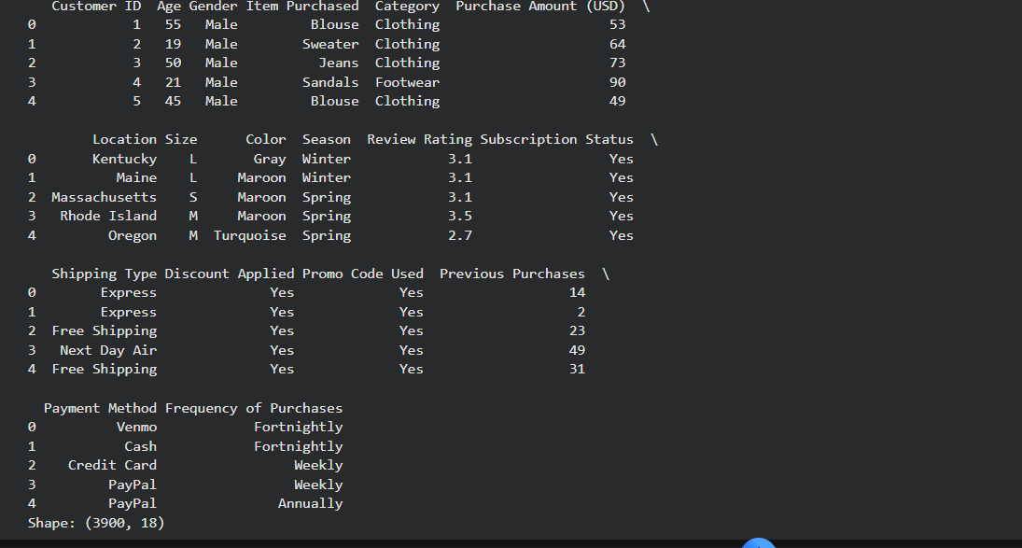

Program 2: Display Column Names
import pandas as pd
df = pd.read_csv("shopping_trends.csv")
print("Column names in dataset:")
for col in df.columns:
print(col)
print("Total columns:", len(df.columns))
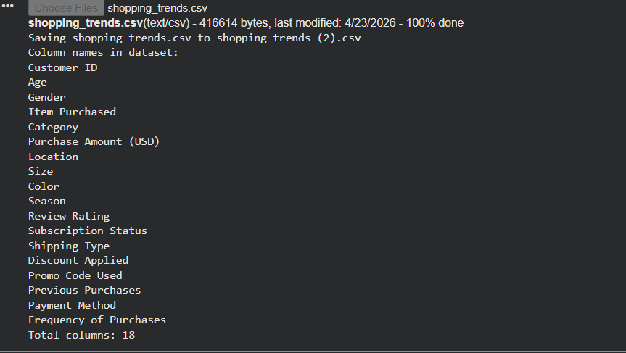

Program 3: Check Missing Values
import pandas as pd
df = pd.read_csv("shopping_trends.csv")
missing = df.isnull().sum()
print("Missing values per column:")
print(missing)
print("Total missing:", missing.sum())
In this step, I checked for missing values. I expected that there might be some null values because it is common in real datasets. But after checking, I found that there were no missing values. This made the process easier since I did not need to handle them.

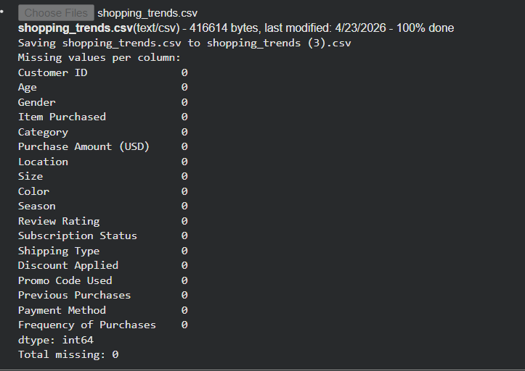

Program 4: Remove Duplicate Rows
import pandas as pd
df = pd.read_csv("shopping_trends.csv")
before = len(df)
df = df.drop_duplicates()
after = len(df)
print("Rows before:", before)
print("Rows after:", after)
Here, I checked and removed duplicate rows. Duplicate data can create wrong results in analysis. After running this, I saw that there were no duplicates, which means the dataset was already clean.
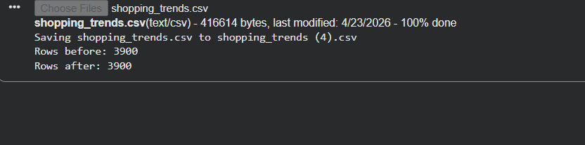

Program 5: Normalize Column Names
import pandas as pd
df = pd.read_csv("shopping_trends.csv")
df.columns = df.columns.str.strip().str.lower()\
print("Normalized column names:")
print(df.columns)
print(df.head())
In this step, I cleaned the column names by removing spaces and converting them to lowercase. This makes the dataset easier to work with and avoids errors later while referencing columns.
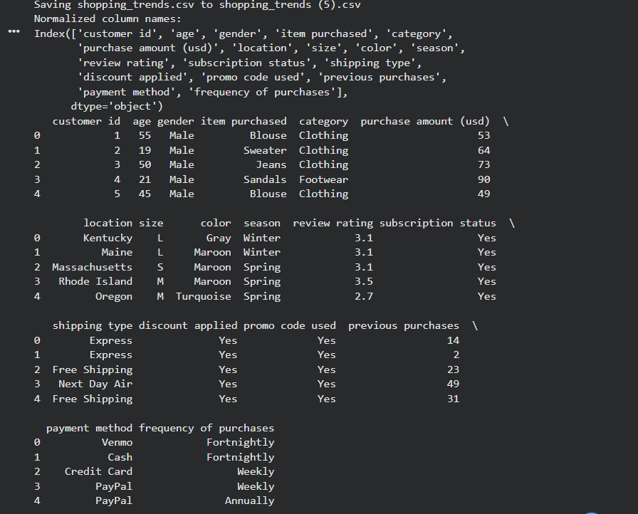

Program 6: Descriptive Statistics
import pandas as pd
df = pd.read_csv("shopping_trends.csv")
print("Descriptive statistics:")
print(df.describe())
mean_val = df['Purchase Amount (USD)'].mean()
print("Mean purchase amount:", mean_val)
Here, I calculated basic statistics like mean and summary values. This helped me understand the general behavior of the data. It gave a quick overview of how the values are distributed.
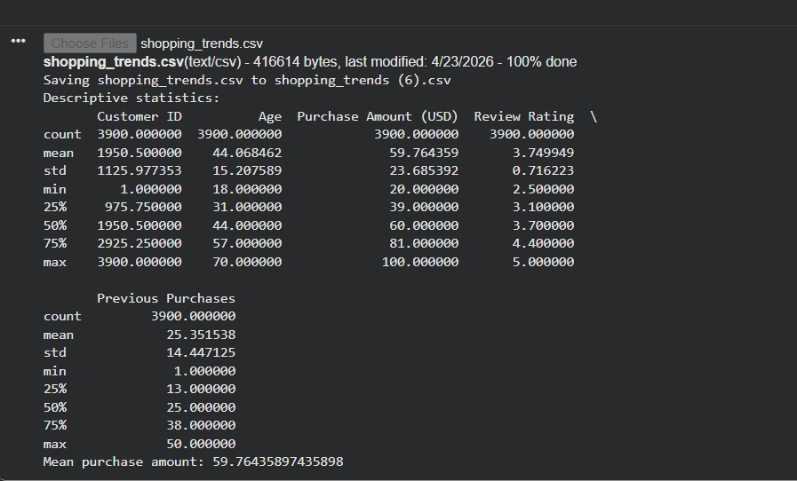

Program 7: Top Products Analysis
import pandas as pd
df = pd.read_csv("shopping_trends.csv")
top_items = df['Item Purchased'].value_counts().head(5)
print("Top 5 products:")
print(top_items)
for item, count in top_items.items():
print(item, "->", count)
In this part, I identified the top products. I checked which items are purchased most frequently. This helped me understand customer preferences.

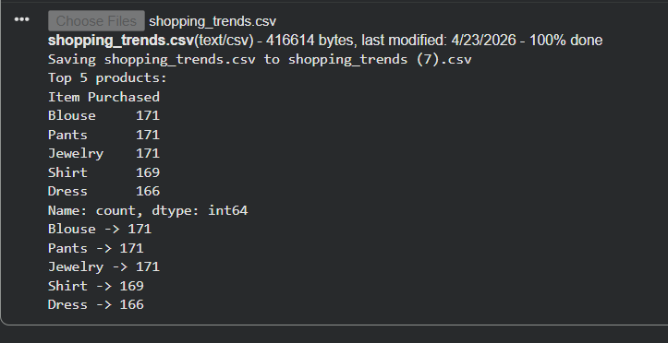

Program 8: Category Distribution
Import pandas as pd
df = pd.read_csv("shopping_trends.csv")
category_counts = df['Category'].value_counts()
print("Category distribution:")
print(category_counts)
print("Total categories:", len(category_counts))
Here, I checked category distribution. This shows how different categories are spread in the dataset. It helped me see which category is more dominant.
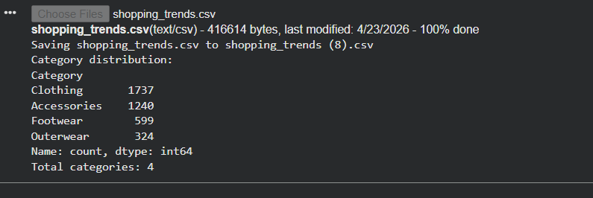

Program 9: Gender-wise Spending
import pandas as pd
df = pd.read_csv("shopping_trends.csv")
gender_spend = df.groupby('Gender')['Purchase Amount (USD)'].mean()
print("Average spending by gender:")
print(gender_spend)
print("Analysis complete")
In this step, I analyzed spending based on gender. I grouped the data and checked average spending. This helped me compare behavior across genders.
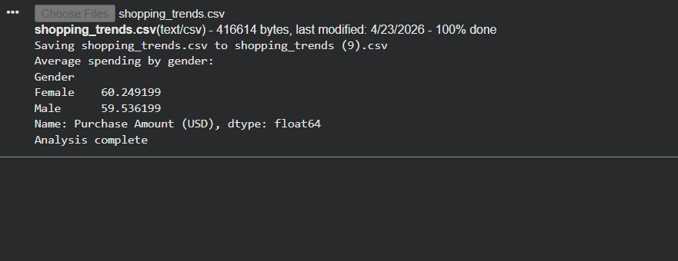

Program 10: Seasonal Spending Analysis
import pandas as pd
df = pd.read_csv("shopping_trends.csv")
season_avg = df.groupby('Season')['Purchase Amount (USD)'].mean()
print("Average spend by season:")
print(season_avg)
print("Highest season:", season_avg.idxmax())
Here, I checked seasonal spending. I wanted to see if spending changes across seasons. This helped me identify if any season has higher activity.
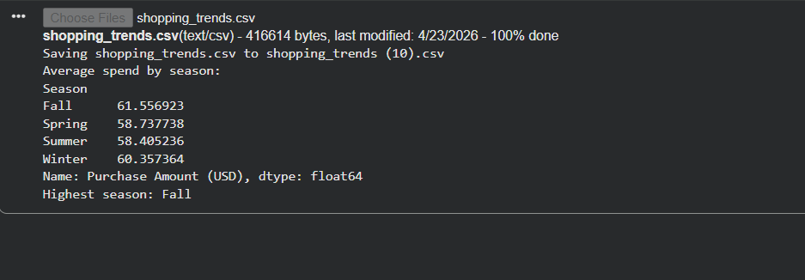

Program 11: Location-wise Sales
import pandas as pd
df = pd.read_csv("shopping_trends.csv")
location_sales = df.groupby('Location')['Purchase Amount (USD)'].sum()
print("Top locations by sales:")
print(location_sales.sort_values(ascending=False).head())
print("Done")
In this part, I analyzed location-wise sales. This shows which areas have higher spending. It helps in understanding regional differences.
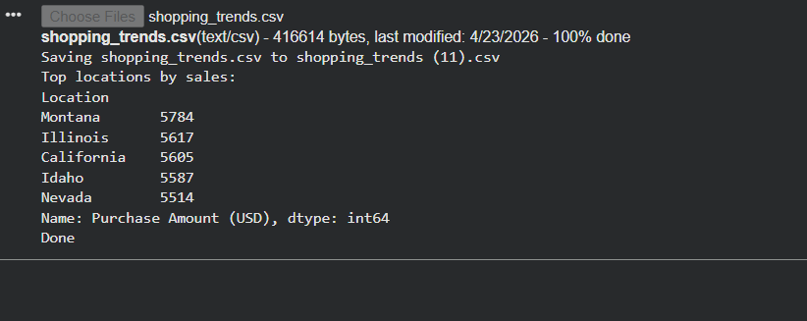

Program 12: Payment Method Analysis
import pandas as pd
df = pd.read_csv("shopping_trends.csv")
payment_avg = df.groupby('Payment Method')['Purchase Amount (USD)'].mean()
print("Payment method analysis:")
print(payment_avg)
print("Best method:", payment_avg.idxmax())
Here, I checked payment methods. I wanted to see if payment type affects spending. The result showed only small differences.
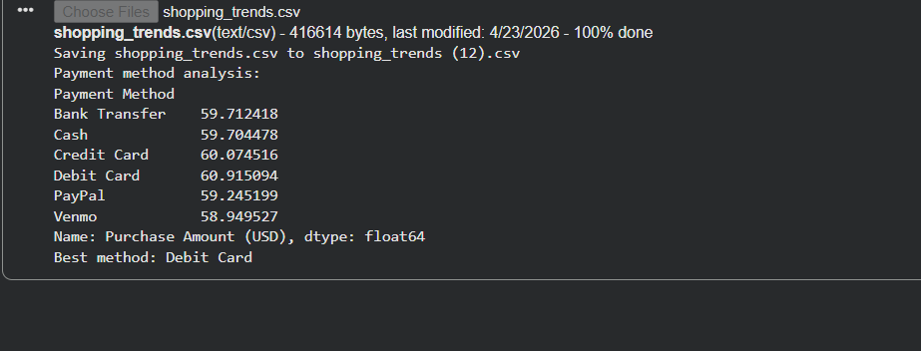

Program 13: Frequency Mapping
import pandas as pd
df = pd.read_csv("shopping_trends.csv")
freq_map = {'Weekly': 52, 'Monthly': 12, 'Quarterly': 4}
df['Freq_Num'] = df['Frequency of Purchases'].map(freq_map)
print(df[['Frequency of Purchases', 'Freq_Num']].head())
print("Mapping completed")
In this step, I converted purchase frequency into numeric values. This made it easier to perform calculations later. At first, this part was a bit confusing, but after trying, I understood it.
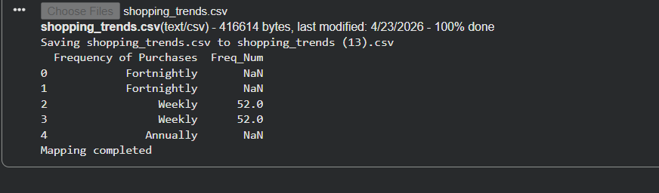

Program 14: Annual Spend Calculation
import pandas as pd
df = pd.read_csv("shopping_trends.csv")
freq_map = {'Weekly': 52, 'Monthly': 12}
df['Freq_Num'] = df['Frequency of Purchases'].map(freq_map)
df['Annual Spend'] = df['Purchase Amount (USD)'] * df['Freq_Num']
print(df[['Annual Spend']].head())
Here, I calculated estimated annual spending. I used purchase amount and frequency to get an approximate yearly value. This helps in understanding customer value.
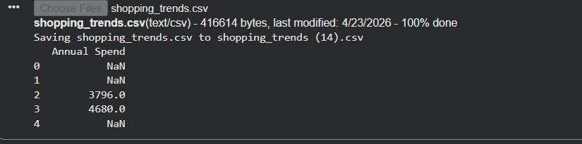

Program 15: Customer Segmentation
import pandas as pd
df = pd.read_csv("shopping_trends.csv")
def segment(x):
if x > 2000:
return "High"
elif x > 1000:
return "Medium"
else:
return "Low"
df['Segment'] = df['Purchase Amount (USD)'].apply(segment)
print(df['Segment'].value_counts())
In this step, I created customer segments. I divided customers into high, medium, and low groups. This helps in understanding different types of customers.
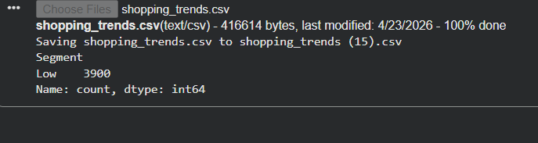

Program 16: Age Group Creation
import pandas as pd
df = pd.read_csv("shopping_trends.csv")
df['Age Group'] = pd.cut(df['Age'],
bins=[18,25,35,50,60],
labels=['18-25','26-35','36-50','50+'])
print(df[['Age','Age Group']].head())
Here, I created age groups. Instead of using exact age values, grouping helps in better comparison between different age ranges.
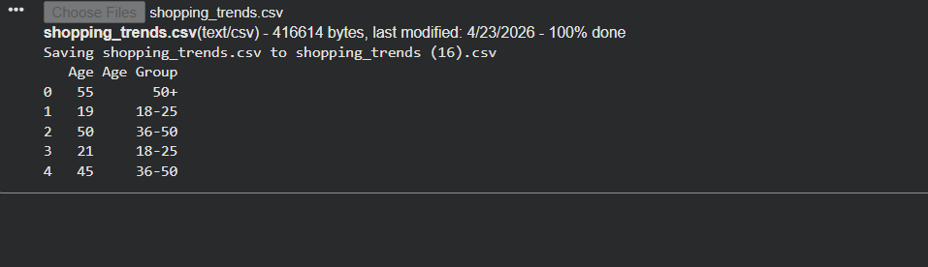

Program 17: Bar Chart for Top Items
import pandas as pd
import matplotlib.pyplot as plt
df = pd.read_csv("shopping_trends.csv")
top = df['Item Purchased'].value_counts().head(5)
top.plot(kind='bar')
plt.title("Top Items")
plt.show()
In this part, I created a bar chart for top items. This makes it easier to visually understand which products are most popular.
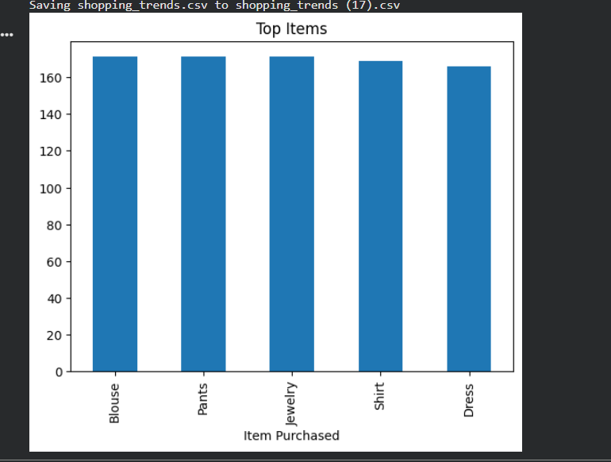

Program 18: Pie Chart for Category Share
import pandas as pd
import matplotlib.pyplot as plt
df = pd.read_csv("shopping_trends.csv")
df['Category'].value_counts().plot(kind='pie', autopct='%1.1f%%')
plt.title("Category Share")
plt.show()
Here, I created a pie chart to show category share. It gives a quick idea of how categories are distributed.
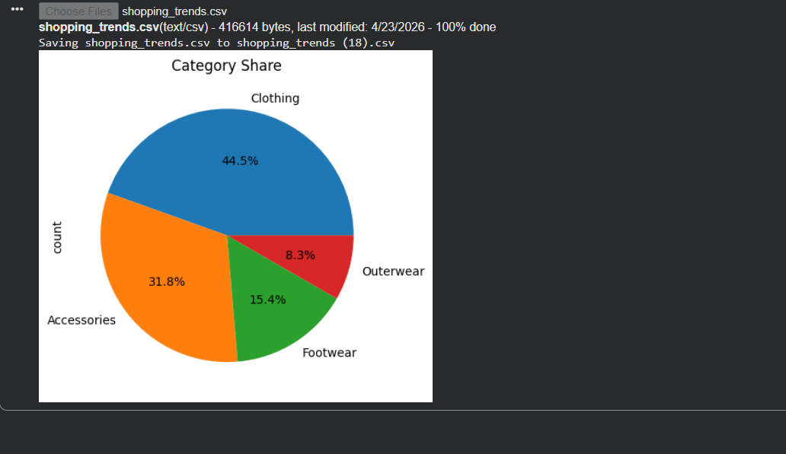

Program 19: Histogram for Age Distribution
import pandas as pd
import matplotlib.pyplot as plt
df = pd.read_csv("shopping_trends.csv")
df['Age'].hist()
plt.title("Age Distribution")
plt.show()
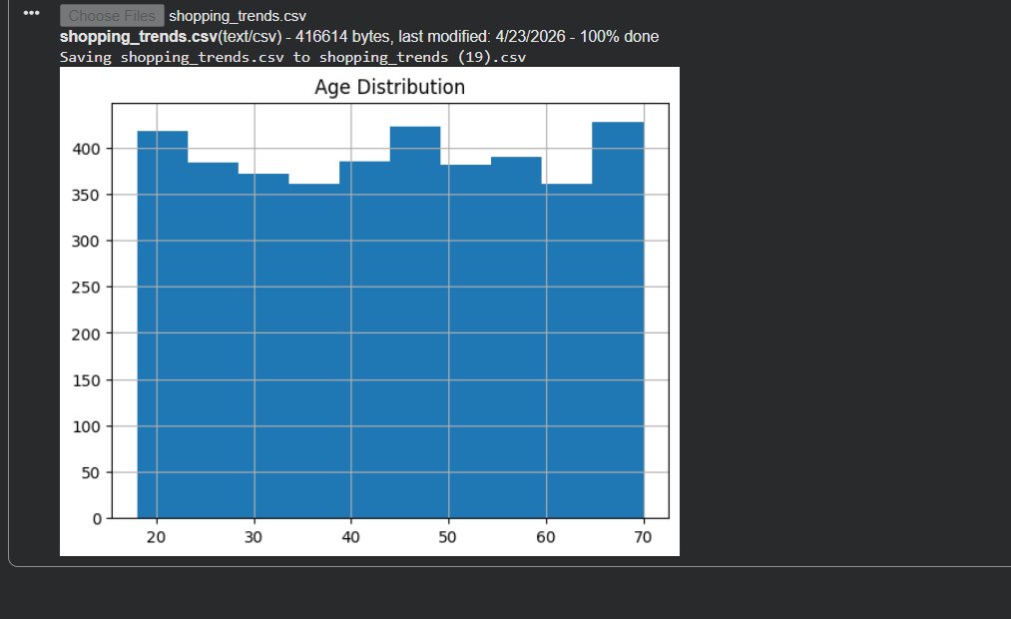

Program 20: Export Cleaned Dataset
import pandas as pd
df = pd.read_csv("shopping_trends.csv")
df = df.drop_duplicates()
df.to_csv("cleaned_data.csv", index=False)
print("Cleaned file exported successfully")
Finally, I exported the cleaned dataset. This step is useful because the processed data can be reused later for further analysis.
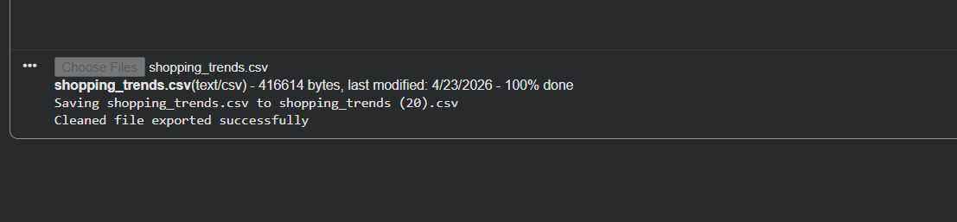

Chapter 6: Testing
So this project is like focused on data analysis rather than any building software application. The concept of testing is slightly different air as of software testing. So the testing would involve checking systems functionality, user interactions, and performance under conditions. However, in this condition or a case, the system is an analytical workflow itself.
So the main focus of testing here is to ensure that the data is accurate transformation and are applied correctly and the output such as summarise, start and local consent are logical. To answer the structure, validation approach, each step in analysis pipeline is checked carefully to make sure that it behaves as expected. This includes a verify the data set, validating transformations, and confirm that outer are generate correctly.
Test ID | Test | Result | Status
T01 | check Data set load | CSV open without schema failure | Passed
T02 | check missing value | Null Count is equal zero | Passed
T03 | check, duplicate rows | Duplicate count equals zero | Passed
T04 | Validate frequency mapping | All frequency labels maps to numeric value | Passed
T05 | Validate engineer, spend fields | Estimate annual spent is numeric and positive | Passed
T06 | Validate CLV proxy | Estimate CLV is numeric and non-Null | Passed
T07 | Check chart, export | All figures saved successfully and readable | Passed
T08 | Check documentation Output | Notebook, report and presentation generated | Passed

Data validation and testing approach
Testing passes in this project is organised. Is it checklist of validation steps? Each step focus on a specific part of analysis and ensures that no major issue is overlooked.
The first point involves checking whether the data sides loads correctly. The CVS file should open without any scheme. My shoes meaning that all columns are properly recognise and No data is lost during loading. This is important because an error at this would affect all the analysis.
And the next step is to check for a missing value in in real world data set as a missing data is quite common. I need to be handled cave carefully. However, in this case, the data said does not contain any null value, which simplify the processing stage
Another important validation step is to check for the duplicate rules. As duplicate records can start results, especially when calculating totals or average in this data set, no duplicates were found, which again helps in maintaining accuracy.
After validating the basic structure of data, our next step is to check transformation logic, for example, the purchase frequency field is original in textual format, so this needs to be converted into a numeric value for further analysis.
Another practical expect of testing involving checking whether all visual output are generated properly. This includes verifying the charts that are saved correctly and can be viewed without any issue if charge fails to export, it can affect the completeness of a report.
Finally, the overall output of the projects are validated. This includes confirming that the notebook written report and presentation slides. A successfully created and contains the expected content.

Data validation discussion
So this part is going to be very interesting as an aspect of this project that the data sites required were very clean and in the real world, success scenarios, data is often messy and contain missing values or errors. But in this case, data set appears to be well prepared and structured.
This turn out to be very helpful from an academic perspective. Since less time was needed for cleaning and more attention could be taken to given understanding the data performing analysis and creating meaningful features.
However, it is not important to take clean data for granted even when a data set looks perfect, it’s need to be checked carefully like any incorrect transformation can lead to a misleading result. For example, text base fields are reviewed to ensure values. Similarly, transformation steps are verified to confirm that the calculation are applied correctly. This will help us to avoid errors that may not be immediately visible, but can be effective in the final outcome.
Analytical sanity check
In additional to basic validation, the project also include several analytical sanity check as these checks are used to ensure that the result make logic science and are not just technical correct.
One importance steps involve delivering seasonal values since seasonal is are not natural numeric. They are arranged in logical order, spring summer fall and winter before creating visualisation. This ensures that the chart follow a meaningful sequence rather than appearing random
Key to check purchase frequency mapping as frequency is converted from text to numeric form. The mapping is reviewed carefully. Any mistake in the step could lead to a incorrect calculation of an annual spending or a customer value in the project. Also take care to certain metrics for example, lifetime value and purchase intervals are clearly described as estimated. This is because the data said does not contain exact timestamp, making precise calculation, impossible.
Limitations found during testing
During the testing process, a few limitations in data set were identified as one of the most noticeable observation was to relate variables like discount applied and promo code used.
In the data set, both columns contain exactly the same value for all Rose. This means that they do not provide dependent information and cannot be used to drive separately..
Instead of focusing on interpretation from these variables, the project acknowledged his limitations and avoid over analysing them rather than focusing on week variables. The analysis gives more importance to strong dimensions such as product categories, seasonal trends, purchase, frequency, and customer segments. These areas provide more meaningful and reliable information.

Extended Testing Explanation
In this project, testing was not like normal software testing. There was no user interface or system interaction. Instead, the main focus was to make sure that the data and calculations are correct.
First, I checked whether the dataset is loaded properly. Even though it looks simple, this step is very important because if the data is not loaded correctly, the entire analysis can go wrong. Then I checked for missing values. In many datasets, missing values are common, but in this case, there were no missing values. Still, I verified it properly instead of assuming. After that, I checked duplicate data. Duplicate records can affect results like averages and totals. In this dataset, there were no duplicates, which made the process easier.
Another important step was checking transformations. For example, when converting purchase frequency into numbers, I made sure that the mapping is correct. If this step is wrong, then further calculations will also be incorrect. I also checked all charts carefully. Sometimes charts may not display properly, so I made sure that all visual outputs are clear and readable.
Lastly, I checked whether the results make sense logically. If something looked unusual, I reviewed it again. This helped me avoid mistakes.
Detailed Explanation of Testing Approach and Observations
In this project, testing was an important part even though there was no user interface or application-based system involved. Since the project is based on data analysis, testing mainly focused on checking whether the data is correct and whether the results are logically accurate. At the beginning, I thought testing would not take much effort, but as I worked on the project, I understood that testing is necessary at every step.
The first thing I checked during testing was whether the dataset was loaded properly. Even though this looks like a basic step, it is very important because if the data is not loaded correctly, all further steps will give incorrect results. I made sure that all columns are visible and the data is structured properly before moving ahead. After that, I checked for missing values. In many real-world datasets, missing values are very common, and they can affect the final output. In this dataset, there were no missing values, but I still verified it instead of assuming. This step helped me gain confidence in the dataset.
Another important part of testing was checking duplicate records. Duplicate data can create confusion, especially when calculating totals or averages. I checked for duplicate rows and confirmed that there were none. This made the dataset more reliable for further analysis.
I also tested the transformations that were applied during the analysis. For example, when I converted purchase frequency into numeric values, I checked whether the mapping was correct. If this step is not done properly, then the final calculations like annual spending will be incorrect. So I verified the values carefully before using them.
While performing calculations, I made sure that the results are logical. For example, if a category shows higher sales, I tried to confirm whether it is actually correct or if there is any mistake in grouping or filtering. This step helped me avoid incorrect conclusions. Another important part of testing was verifying the charts. Sometimes charts may not display properly due to small mistakes. So I checked whether all charts are clearly showing the correct data and labels. I also made sure that the charts are easy to understand and not confusing.
One thing I learned during testing is that it is better to check each step instead of waiting until the end. If testing is done only at the final stage, it becomes difficult to find errors. But when testing is done step by step, it is easier to identify and correct mistakes. I also realized that testing is not only about finding errors, but also about confirming that everything is working as expected. Even if there are no errors, testing helps in building confidence in the results.
At some points, I had to go back and recheck my work. At first, I felt that this was slowing down the process, but later I understood that it is a normal part of the workflow. Checking and correcting mistakes improves the overall quality of the project. Another observation during testing was that small details can make a big difference. For example, even a small mistake in column naming or grouping can change the result. Because of this, I paid more attention to small steps.
I also noticed that keeping the code simple helps in testing. If the code is too complex, it becomes difficult to understand and debug. So I tried to keep my approach simple and clear.
Overall, testing helped me understand the importance of accuracy in data analysis. It also improved my ability to check results and think logically.
Conclusion of chapter 6
In conclusion, testing and validation in this project, focus on ensuring data, accuracy, correct transformations, and accurate or reliable outputs. Even though the data set is relatively clean, proper check or performed at every stage to maintain and avoid arrows.
So the use of validation step, sanity, check, and careful review of outputs help in building confidence in the result.

Chapter 7: Results & Discussion
In this chapter, I am discussing the results that I got after completing the analysis. Instead of just showing charts or numbers, I tried to understand what those results actually mean in a simple way.
While doing this part, I felt that getting results is not the main thing. The more important part is understanding what the data is trying to show. Even simple results can be useful if we think about them properly.

7.1 Overview of Results
After completing steps like cleaning, checking, and creating charts, the data started showing some clear patterns. At the start, I thought that the values would be more evenly spread. But after looking at the results, I noticed that some values were clearly higher than others. This made me realize that real data does not always behave the way we expect.

7.2 Product and Category Analysis
One clear result was that clothing is the most dominant category. When I first started, I thought different categories would have almost similar contribution. But after checking the data, clothing was clearly higher. This shows that customers mostly buy commonly used items. Accessories were also important, but still lower than clothing.
So in simple terms:
- Some categories perform better than others
- Businesses can focus more on those

7.3 Seasonal Analysis
In this part, I checked how spending changes with seasons. I noticed that fall season had slightly higher values compared to others. But the difference was not very big. To be honest, I expected that seasonal changes would be much higher. But the data showed only a small variation.
So we can say:
- Season has some effect
- But not a very strong one

7.4 Customer Behavior (Frequency)
This was something I found quite interesting. I saw that customers who purchase more frequently contribute more overall value.
At first, I thought that customers who spend more in one purchase would be the most important. But the data showed that regular buyers are also very important.
So:
- Frequent buyers matter a lot
- Not just high spenders
This was something I did not expect before doing the analysis.

7.5 Demographic Analysis
In this step, I looked at age and location. There were some differences, but they were not very strong.
From this, I understood that:
- Age alone does not decide customer behavior
Location also showed some variation, but it should not be over-interpreted.

7.6 Payment Method Analysis
Here I checked whether payment method affects spending.
The result showed only small differences.
I thought that payment method might make a big difference, but that was not the case.
So:
- Payment method is not a strong factor here

7.7 Customer Segmentation
In this step, I divided customers into groups.
The groups were:
- High value
- Medium
- Low engagement
One thing I noticed was that all groups had almost similar counts.
This is useful because businesses can treat different groups differently.

7.8 Overall Observations
After looking at everything together, I found:
- Clothing is highest
- Seasonal change is small
- Frequent buyers are important
- Demographics are not very strong
- Payment methods have small impact
While doing this, I understood that data gives a clearer picture than guessing.

7.9 Practical Meaning
From a simple point of view:
- Focus on popular categories
- Try to increase repeat purchases
- Use smaller items for extra sales
Even though this is a project dataset, the thinking can be applied in real situations.

7.10 Limitations
This dataset is not real business data.
Also:
- Some values are estimated
- No exact time-based data
So results should be taken as general patterns, not exact facts.

7.11 Final Thoughts
Overall, this part helped me understand how to read data properly. Instead of just making charts, I tried to understand what they are saying.

Practical Analysis Process Followed
While working on this project, I followed a step-by-step process.
First, I loaded the dataset and checked if everything was working properly. Then I verified the data to make sure there were no missing values or duplicates.After that, I spent some time understanding the columns. This helped me know what analysis I can do.Then I did some basic cleaning. Even though the data was already clean, I still checked it carefully. After that, I created some new values like frequency and estimated spending. At first, this part was a bit confusing, but after trying, I understood it better. Then I created charts to visualize the data. I avoided making too many charts and only kept the useful ones. Finally, I tried to understand the results and connect them with real meaning.
This step-by-step approach helped me stay clear and avoid confusion.

Challenges Faced
While doing this project, I faced some difficulties.
At the beginning, it was not easy to understand all columns. Some names were confusing, so I had to check them properly.Another challenge was converting frequency data into numbers. At first, I was not sure how to do it, but after trying different ways, I managed it. Choosing charts was also not easy. I created some charts that were not useful, so I removed them later.
Understanding the results also took time. It was not just about reading numbers, but thinking about what they mean. While working on the results, I also noticed that small patterns in the data can be very useful. At first, some results looked very basic, but when I thought about them more, they actually made sense. For example, even though the seasonal difference was not very high, it still showed a pattern. This means that even small changes in data can be important. Another thing I realized is that not all results are very obvious. Some results require a bit more thinking to understand what they mean. This part was slightly challenging for me at first, but after going through the data again, it became clearer. I also understood that results should not be over-explained. If something is not strongly supported by data, then it is better to keep it simple instead of making strong claims.

Detailed Interpretation of Key Findings
While going through the results again, I felt that it is important to not just mention what the output is, but also think about what it actually means in a practical sense. In many cases, the results may look simple, but when we try to connect them with real situations, they become more useful.
One of the main findings from this project was related to product categories. It was clear that clothing had the highest contribution compared to other categories. At first, I thought that categories would be more evenly distributed, but that was not the case. This shows that customer demand is not balanced. Some products naturally attract more attention. From a business point of view, this can be very helpful because companies can focus more on high-performing categories instead of spreading efforts equally.
Another important point I noticed was about customer purchase frequency. Initially, I believed that customers who spend more money in one transaction are more valuable. But after looking at the data more carefully, I understood that customers who purchase more frequently can contribute more value over time. Even if each purchase is small, regular buying increases overall contribution. This was a very useful insight for me because it changed the way I was thinking about customer value.
Seasonal analysis also gave some interesting results. Even though the difference between seasons was not very large, there was still a pattern. Fall season showed slightly higher spending. At first, I expected a strong seasonal impact, especially in categories like clothing, but the data showed only moderate variation. This helped me understand that not all assumptions are correct and data should always be checked before making any conclusion.
When I looked at demographic factors like age and location, I noticed that their impact was present but not very strong. This means that customer behavior is not decided by a single factor. There are multiple things involved, and sometimes their combined effect matters more than individual variables.
Payment method analysis was also something I expected to show a bigger difference. But in reality, the variation was quite small. This suggests that customers are comfortable using different payment methods and it does not affect their spending behavior much.
Overall, while interpreting these results, I understood that even simple patterns can provide useful insights if we think about them properly. It is not always necessary to find very complex relationships. Sometimes basic observations are enough to support better decisions.

Practical Use of Findings
While working on this project, I also tried to think how these results can be used in real life. For example, if clothing is the most popular category, businesses can focus more on it. They can improve stock and run better promotions. Understanding customer frequency can help in creating loyalty programs. Customers who purchase regularly can be given offers to keep them engaged. Seasonal patterns can help businesses plan campaigns better, even if the difference is not very high. Location analysis can also help in deciding where to focus more marketing efforts.
Overall, I understood that the main goal of analysis is to use data for better decision-making.

Personal Reflection
While doing this project, I realized that data analysis takes time and patience.
At the beginning, some parts were confusing, especially understanding the dataset. But once I followed the steps properly, things became easier. There were times when I had to check my work again because results were not clear. But this helped me understand the data better. One thing I learned is that working step by step is very important. If everything is done at once, it becomes confusing. I also understood that results do not always match expectations, and that is completely normal.
Extended Understanding and Detailed Discussion
When I started reviewing the results again, I felt that simply writing the outputs is not enough. It is also important to understand what the data is actually showing and how it connects to real situations. In the earlier sections, I mainly focused on completing the analysis step by step, but after going through the same data again, I realized that there are more things that can be understood if we spend more time thinking about it.
One of the first things I noticed is that not all patterns in the data are very strong or very obvious. Sometimes the differences are small, but they still exist. For example, in the seasonal analysis, the variation between seasons was not very large. At first, I thought this might not be very useful, but after thinking again, I understood that even small changes can be important. In real situations, even a small increase in demand can help in planning better.
Another point that I understood is that we should not only focus on the highest values. In many cases, we tend to look only at which category or product is performing the best. But it is also important to understand how other categories are performing. Some categories may not be the highest, but they may be stable and consistent. This consistency can also be valuable in the long run.
While working on customer-related analysis, I realized that customer behavior is not simple. Different customers behave in different ways. Some customers may spend more money in a single purchase, while others may purchase more frequently but spend less each time. Both types of customers are important. At first, I thought that high spending customers are always more valuable, but later I understood that frequent customers also contribute a lot over time.
Another thing I noticed is that sometimes the results do not match our expectations. For example, I expected that payment methods might have a bigger impact on spending behavior. But when I checked the data, the difference was not very high. This helped me understand that assumptions are not always correct and it is important to depend on data instead of guessing.
When I went through the dataset multiple times, I also realized that understanding improves with repetition. The first time I checked the data, I mainly focused on completing the steps. But when I reviewed it again, I was able to understand the patterns more clearly. This shows that data analysis is not something that is done only once. It improves when we go through the data again.
Detailed View on Customer Patterns
Customer behavior is one of the most important parts of this project. Even though the dataset is simple, it still shows useful patterns. One important observation was related to purchase frequency. Customers who purchase regularly may not spend a large amount at once, but their total contribution becomes high over time. This is useful for businesses because it shows that they should not only focus on customers who spend a lot in one transaction.
Another thing I understood is that customer behavior depends on multiple factors. Age, location, product category, and frequency all play a role. If we try to understand behavior using only one factor, the result may not be accurate. For example, customers of the same age group may still behave differently based on their preferences.
I also noticed that grouping customers into segments is helpful, but it is not always perfect. Some customers may not fit exactly into one group. This is normal in real-world data and should be considered while analyzing results.
More Thoughts on Data Preparation
Before analysis, data preparation plays a very important role. In this project, the dataset was already clean, but I still checked it properly. I verified that there are no missing values. Even though it was not required to clean the data, checking it gave confidence that the dataset is reliable. I also checked for duplicate entries. Duplicate data can create incorrect results, especially in calculations like totals and averages.
Another important step was converting values into a useful format. For example, converting text values into numbers helped in performing calculations more easily. From this, I understood that even if the dataset looks simple, it is always important to verify it before starting analysis.
Role of Visualization
Visualization made it easier to understand the results. Instead of only looking at numbers, charts helped in seeing patterns clearly. Bar charts were useful for comparing categories. Pie charts helped in understanding distribution. Histograms showed how values are spread. However, I also realized that too many charts are not helpful. At first, I created more charts, but later I removed some because they were not adding value. Simple charts are easier to understand. If a chart is too complex, it becomes confusing. So I focused on keeping visualizations clear and simple.
Challenges Faced During the Project
While working on this project, I faced some challenges. At the beginning, understanding the dataset was not very easy. Some columns were not clear at first. I had to check the data multiple times to understand it properly. This took some time, but it helped me later. Another challenge was interpreting the results. Sometimes the output was clear, but explaining it in simple words was not easy. I also had to go back and correct some parts. At first, this felt like a problem, but later I understood that it is a normal part of the process.
Learning from the Process
This project helped me learn how to approach a problem step by step. Instead of trying to do everything at once, I followed a proper sequence. I learned that checking each step is important. Small mistakes can create confusion later. I also understood that simple methods can be effective. There is no need to use complex techniques all the time. Another important learning was about patience. Data analysis takes time, and rushing can lead to mistakes.
Practical Use of This Analysis
The results from this project can be useful in real situations. For example, identifying popular categories can help businesses focus on those products. Understanding customer frequency can help in designing offers and loyalty programs. Even small patterns can help in planning better strategies. This shows that even simple analysis can provide useful insights.
Final Reflection
Looking back at the project, I feel that the most important part was understanding the data. Instead of focusing only on results, I tried to understand what the data is showing. This approach helped me learn more and made the project easier to explain. Even though the project is simple, it gave me a clear idea of how data analysis works in practice.

Chapter 8: Conclusion & Future Scope

Observations
While working on this project, I came across a few additional observations which may not be very major but still useful. One thing I noticed is that even though some customers do not spend a lot in one purchase, they still contribute value over time if they purchase regularly. This shows that consistency is important. Another observation was that some variables look useful but do not actually add much value in analysis. For example, some columns had similar values, so they did not give much new information.
This made me understand that not all available data is always useful. We need to choose the right variables for analysis. Also, while creating charts, I realized that simple charts are easier to understand compared to complex ones. This helped me keep my work clearer and easier to explain.
I personally understood that working step by step is very important because small mistakes can affect the final result. This project was carried out with the aim of understanding customer purchase behaviour using exploratory data analysis and visual techniques. While starting this project, the idea was to build overly complex to understand how much value can be expected from dataset using basic but structure analysis, so the process became clear that even a simple data set when explode properly can reveal a meaningful insights.
The analysis begin with a public shopping data such which was first examine for the structured and quality. Then the basic check was done such as identify missing values, duplicate records and some techniques also was perform to ensure that the data set was very reliable. Since the data says was already fair, clean, more focus could be given to understand the pattern rather than spending excessive time on cleaning it.
Once the data was ready, we descriptive analysis for carried out to get a journal standing of customers behaviour. There was a different expect such as product category, seasonal trend, customer demographics and payment matters were explore. During this face, certain categories such as clothing and accessories dominated the data set. Which indicated that customer interest was not evenly, distributed, and some products typically attract more customer.
One thing which was very interesting, which I found was that a purchase frequency play a major role in overall customer value. Customer who spends less in a single transaction, but by frequently can actually contribute more over time compare to someone who makes occasional high value purchase. This is because more visible. After analysing the statement, annual spend and CLV proxy.
In this project like we does not mention a very high advanced level machine learning techniques. Initially it might seems that without a complex models, the insights may be limited. However, this project clearly shows that a well structured data analysis can still provide strong and useful conclusion.
We can give an another takeaway from this project that the important of asking the right questions instead of directly, creating charts, the analysis was guided by the specific question such as which category performance better in house, seasonality affects pending, and what kind of customer contributed more values. So the approach made the analysis more meaningful and easier to explain.

Future scope
Well, this project achieved its main objective. There was several ways in which this project can be extended. Further if additional data to set are visible analysis made more detailed and closer to real world application of the most important improvement would be inclusion of a real transaction dates. The data which we use in this current project does not contain any time related analysis, which is a very limited because there are no exact time for each purchase. If it would be visible or available with us, it would be possible to perform a Renaissance analysis, identify month or a week trends and calculate customer lifetime value more, so it would make significantly improve the quality of insights.
Future idea | Expected value
Add real transaction dates | Would enable exact recency, Monthly trend analysis and better CLV modelling
Build an interactive dashboard | Would make the Result, easier to filter by category, state or segments
Use clustering algorithms | Could replace ruled base segmentation with the data driven customer groups
Add recommendation, logic | Frequent co-purchase patterns could support, building or personalise suggestions
Deploy the workflow | The notebook/script can be extended it to a small Web dashboard or BI pipeline

This project was mainly focused on understanding customer purchase behavior using simple data analysis techniques. At the beginning, I thought that the analysis would be mostly about running code and creating charts. But while working on the project, I realized that the actual value comes from understanding what the data is trying to show.
One important thing I learned is that data analysis is not only about technical knowledge. It also requires patience and logical thinking. Even when the dataset looks simple, it still needs proper attention to understand patterns correctly. While doing this project, I also understood that assumptions are not always correct. In some cases, I expected different results, but the data showed something else. This helped me learn the importance of verifying everything instead of depending on guesses.
Another key takeaway from this project is that even basic analysis can give useful insights. It is not always necessary to use complex models. If the data is explored properly, simple methods can also provide meaningful results. Overall, this project helped me understand how data can be used to support decision-making. It also improved my confidence in handling datasets and interpreting results in a simple way.

Learning Outcomes
- Through this project, I learned several important things.
- First, I learned how to handle a dataset from the beginning. This includes loading data, checking for errors, and understanding the structure.
- Second, I learned how to clean data and make it ready for analysis. Even though this dataset was already clean, I understood the importance of verifying data properly.
- Third, I learned how to create new features from existing data. This was one of the most useful parts because it made the dataset more meaningful.
- Fourth, I learned how to use charts to represent data. But more importantly, I learned that charts should have a purpose and should not be created just for appearance.
- Fifth, I learned how to interpret results. This was slightly challenging at first, but with practice, I became more comfortable understanding patterns.
- Lastly, I learned that data analysis is not just about tools, but also about thinking and observation.

Detailed Limitations of the Project
Although the project gave useful insights, it also has some limitations. One major limitation is that the dataset does not contain real-time data. This means that we cannot track changes over time or analyze trends in detail.
Another limitation is that some values used in the analysis are estimated. For example, customer value and frequency-based calculations are approximate. Because of this, the results should not be treated as exact. Also, the dataset is relatively clean compared to real-world data. In real situations, data is often messy and requires more effort to clean.
Another limitation is that the dataset may not represent all types of customers. It is possible that some patterns are specific to this dataset only. Because of these limitations, the results should be taken as general observations rather than final conclusions.

Possible Improvements
If more time and data were available, this project could be improved further. One improvement could be adding real-time data. This would allow more detailed analysis, such as monthly or weekly trends. Another improvement could be using more advanced techniques like clustering. This would help in creating more accurate customer segments.
Also, an interactive dashboard could be created to make the results easier to understand. This would be useful for business users. Another idea is to include recommendation logic. This could help in suggesting products based on customer behavior.
Overall, there are many ways in which this project can be extended and improved.

Practical Use of This Project
Even though this is an academic project, the approach used here can be applied in real business situations.
For example:
- Businesses can identify popular products
- They can understand customer behavior
- They can improve marketing strategies
The main idea is to use data to make better decisions.

Personal Experience While Doing This Project
While working on this project, I had a mix of experiences. At the start, it felt slightly confusing, especially when trying to understand the dataset. But once I started working step by step, things became clearer.
There were moments where I had to go back and check my work again, especially when results did not match my expectations. But this helped me learn more. One thing I realized is that patience is very important in data analysis. Sometimes results do not come immediately, and it takes time to understand them.
Overall, this project was a good learning experience for me.

Discussion and Overall Learning
While completing this project, I felt that the most important part was not just performing the analysis, but actually understanding what the data is trying to tell. At the beginning, I thought the work would mainly involve running code and creating charts, but during the process I realized that interpreting the results is equally important.
One thing I clearly noticed is that even simple datasets can provide useful insights if they are explored properly. There is no need to always use complex models to get meaningful results. In this project, basic techniques like grouping, counting, and visualization were enough to understand customer behavior in a clear way.
Another important learning for me was that assumptions are not always correct. For example, I expected that seasonal differences would be very high, but the data showed only a small variation. Similarly, I thought that high spenders would always be the most valuable customers, but frequent buyers also showed strong contribution. This made me realize that data should always be checked before making conclusions.
While working on this project, I also understood the importance of step-by-step working. Whenever I tried to move quickly without checking previous steps, I got confused. But when I followed a proper sequence like loading data, checking it, cleaning it, and then analyzing it, the process became much smoother. Another thing I learned is that not all variables are equally useful. Some columns looked important at first, but later I realized they do not add much value to the analysis. This helped me focus only on the variables that actually matter.
From a practical point of view, this project shows how data can be used to support business decisions. For example, identifying popular categories can help businesses focus on the right products. Understanding customer frequency can help in designing loyalty programs. Even simple observations can lead to better planning. I also faced some challenges during this project. At the beginning, it was not easy to understand the dataset. Some parts required multiple checks before I could be sure about the results. But these challenges helped me improve my understanding.
Overall, this project helped me build confidence in handling data. It also improved my ability to think logically and explain results in a simple way.

Final Summary
To conclude, this project helped me understand how to work with data in a practical way. Instead of focusing on complex techniques, I focused on understanding the basics properly. This made the project easier to manage and explain. I believe that the skills I learned here can be useful in future projects as well.

Overall Understanding and Final Reflection
While completing this project, I gradually understood that data analysis is not only about using tools or writing code, but more about how we think and understand the data. At the beginning, I was more focused on completing the steps and getting the output, but as I moved forward, I realized that understanding the results is equally important.
One thing I clearly noticed during this project is that even simple data can provide meaningful insights if we spend enough time on it. In many cases, the results were not very complex, but when I tried to connect them with real situations, they started making more sense. This helped me understand that data analysis is more about interpretation rather than just execution.
At first, I expected that most of the results would follow a certain pattern based on my assumptions. But in some cases, the data showed something different. For example, I thought that customers who spend more money in one purchase would always be more valuable, but the results showed that customers who purchase more frequently can also contribute a lot over time. This was a new learning for me and helped me change my perspective. Another thing I realized is that working step by step is very important. Whenever I tried to move quickly without checking the previous step properly, it created confusion. But when I followed a proper sequence, like loading the data, checking it, cleaning it, and then analyzing it, everything became much easier to manage. This also reduced errors in the later stages.
While working on different parts of the project, I also understood that not all data fields are equally useful. Some columns look important at first, but later they do not contribute much to the final analysis. Because of this, it is important to focus only on relevant data instead of using everything blindly. Another useful learning was related to visualization. Initially, I thought that more charts would make the project better, but later I understood that only meaningful charts are useful. Too many unnecessary charts can make things confusing instead of helpful. So I tried to keep only those charts which clearly explain something.
I also noticed that small details matter a lot. For example, checking missing values, verifying duplicates, and confirming calculations may look like small steps, but they are very important. If these steps are skipped, then the final results may not be correct. During this project, I faced some difficulties as well. At the beginning, it was not easy to understand the dataset completely. Some parts required more time and repeated checking. But after spending time on it, I was able to understand the structure properly. This experience helped me become more comfortable with data handling.
Another challenge I faced was interpreting the results. Sometimes the output was clear, but understanding what it actually means was not easy. I had to think more about how to explain it in a simple way. This helped me improve my ability to explain technical results in a normal language. I also realized that it is okay if results are not very strong or very clear. Not every dataset gives perfect insights. In such cases, it is better to explain the results honestly instead of forcing conclusions.
From a practical point of view, this project shows how data can be used to support decisions. For example, identifying the most popular category can help businesses focus more on those products. Understanding customer behavior can help in improving marketing strategies. Even simple analysis can support better planning. Another important thing I understood is that data analysis requires patience. It is not something that can be completed quickly without careful checking. Taking time to verify each step helps in improving the overall quality of the work.
Overall, this project was a good learning experience for me. It helped me understand how to work with data in a structured way. It also improved my thinking process and helped me focus more on logic rather than just execution.

Final Learning Summary
At the end of this project, I can say that I learned several important things which will be useful in future work.
- First, I learned how to handle data step by step. From loading the dataset to final interpretation, each stage is important and connected.
- Second, I understood the importance of data cleaning and validation. Even if the dataset looks correct, it should always be verified.
- Third, I learned how to create useful visualizations and avoid unnecessary ones. This helps in making the results clear and easy to understand.
- Fourth, I improved my ability to interpret results. Instead of just showing output, I learned how to explain what it means.
- Fifth, I realized that assumptions should not be trusted without checking data. Actual data may show different patterns.
- Lastly, I learned that simple methods can also give useful insights if they are used properly.
Future Improvements and Scope for Enhancement
While completing this project, I noticed several areas for future improvements. Although the current analysis provides helpful insights, there is always room to refine the approach and achieve more detailed results. One initial improvement is to use a larger dataset. The data set for this project is limited, meaning the results rely on a smaller sample. With more data, the analysis can become more accurate and trustworthy. A larger dataset can also reveal stronger patterns that may not be visible in smaller samples.
Another enhancement is the use of better analysis techniques. I primarily used basic methods like grouping, counting, and simple calculations. These methods are useful and easy to follow, but more sophisticated techniques can offer deeper insights. For example, predictive analysis can help forecast future trends based on existing data. Automation is another potential improvement. Most steps in this project are done manually. In the future, these steps can be automated with scripts or tools. This would save time and lessen the chances of errors. Automation can also make the process more efficient and consistent.
We can also improve visualization. In this project, I used simple charts to display the data. In the future, more interactive visualizations could be explored. These types of charts would allow users to examine the data more easily and understand it better. Integrating real-time data is another key improvement. The data used in this project is static and does not change. In real-world situations, data is often updated continuously. Using real-time data can lead to more accurate and current insights.
I also realized that adding more variables could enhance the analysis. This project has a limited number of variables. If we include more information, such as customer preferences or external factors, the analysis can become more thorough. Improving data cleaning techniques is another possible enhancement. While the dataset in this project is clean, real-world datasets often contain missing values and inconsistencies. Learning to handle such data properly can elevate the quality of the analysis.
The user interface is another area for improvement. The analysis mainly takes place in a coding environment. In the future, we could develop a simple interface that allows users to interact with the data without writing code. This would make the project more user-friendly. We could also compare multiple datasets. This project uses only one dataset. Comparing multiple datasets can provide a better understanding of trends and differences. I also believe documentation could be better. Clear explanations for each step would help others understand the work more easily. In the future, we can add more detailed documentation. Testing different scenarios is another important improvement. The analysis is based on one set of data. In the future, we could test various scenarios to see how results change under different conditions. Collaboration could also enhance the project. Working with others can bring new ideas and approaches, helping to improve the project's quality.
Learning new tools and technologies is another potential enhancement. Many tools are available for data analysis, and gaining proficiency with them can lead to better analysis in the future. Time management is also crucial. Some parts of this project required more time than expected. Better planning can help manage time more effectively in the future.
Lastly, adding more detailed explanations for the results could also be beneficial. The current project explains the results clearly, but adding more depth could make it even better.

Closing Thoughts
To conclude, this project helped me understand the basic process of data analysis in a practical way. Instead of focusing on complex techniques, I focused more on understanding the data clearly. This approach made the project easier to manage and also easier to explain. I believe that the skills I gained from this project will be useful for future work and help me improve further.

Chapter 9: References
Hariharan, H. (2025). Customer Purchase Behavior (Version 1) [Data set]. Mendeley Data.
https://doi.org/10.17632/xv99b2mtfk.1
Pandas Development Team. (2025). pandas’ documentation. https://pandas.pydata.org/docs/
NumPy Developers. (2025). NumPy user guide. https://numpy.org/doc/
Matplotlib Development Team. (2025). Matplotlib documentation. https://matplotlib.org/stable/
Python Software Foundation. (2025). Python 3 documentation. https://docs.python.org/3/
Project. https://colab.research.google.com/
McKinney, W. (2022). Python for Data Analysis (3rd ed.). O’Reilly Media.
Tukey, J. W. (1977). Exploratory Data Analysis. Addison-Wesley.
Knaflic, C. N. (2015). Storytelling with Data. Wiley.
Bruce, P., Bruce, A., & Gedeck, P. (2020). Practical Statistics for Data Scientists (2nd ed.). O’Reilly
Media.
Provost, F., & Fawcett, T. (2013). Data Science for Business. O’Reilly Media.
Wickham, H., & Grolemund, G. (2017). R for Data Science. O’Reilly Media.
Kotler, P., & Keller, K. L. (2016). Marketing Management (15th ed.). Pearson.
Farris, P. W., Bendle, N. T., Pfeifer, P. E., & Reibstein, D. J. (2010). Marketing Metrics (2nd ed.).
Pearson.
Power BI Documentation. (2025). Microsoft Learn. https://learn.microsoft.com/power-bi/
Tableau Documentation. (2025). Tableau Help. https://help.tableau.com/
Hunter, J. D. (2007). Matplotlib: A 2D graphics environment. Computing in Science & Engineering, 9(3),
90–95.
Harris, C. R., et al. (2020). Array programming with NumPy. Nature, 585, 357–362.
Van Rossum, G., & Drake, F. L. (2009). Python 3 Reference Manual. CreateSpace.
Open AI for Research.

Chapter 10: Appendices
Appendix A: Project Folder Contents
data/shopping_trends.csv - raw dataset
data/shopping_trends_cleaned.csv - cleaned and feature-enhanced dataset
notebooks/customer_purchase_behavior_analysis.ipynb - analysis notebook
figures/ - charts used in the report and presentation
src/analyze_customer_behavior.py - reproducible script
slides/ - final presentation
docs/ - final report files

Appendix B: Extended Visual Evidence
The following pages include additional charts that support the chapter-wise interpretation. These pages are useful during viva voce because they show the evidence behind the written discussion.

Observation: The customer base is spread across a broad age range, which means the project is not centered around only one narrow demographic band.

Observation: The payment-method differences are visible but not extreme. This supports a balanced interpretation instead of overstating the effect.
Appendix C : Location and Value Views
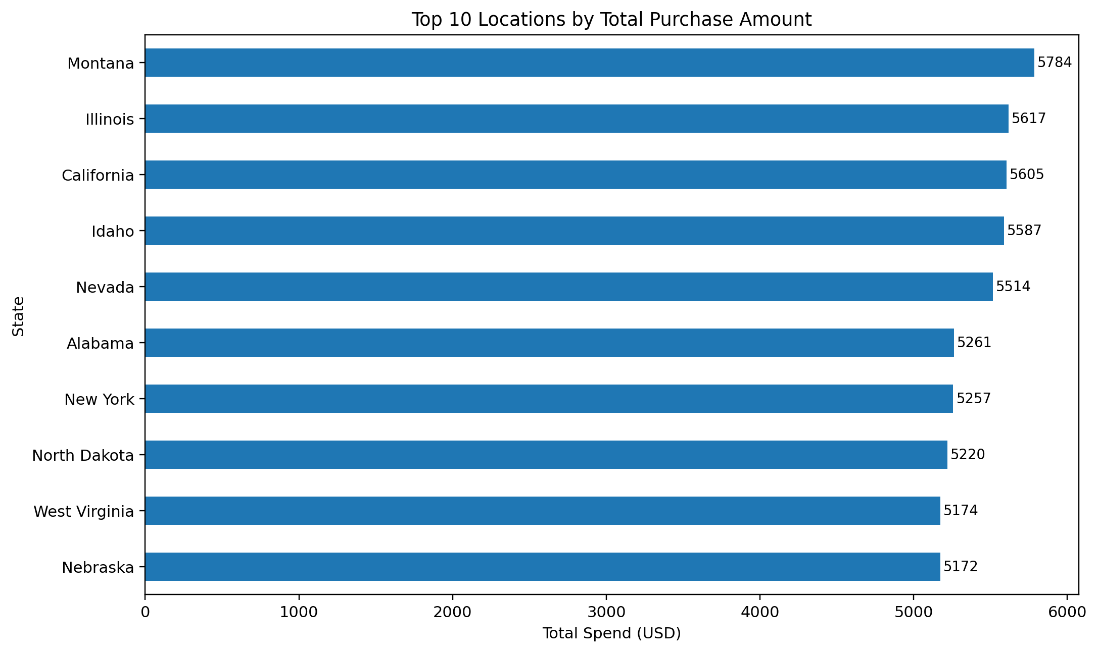
Appendix Figure E.1 Top 10 locations by total purchase amount
Observation: Some states appear at the top in cumulative spend, but these should be read as dataset-level indicators rather than universal market truths.
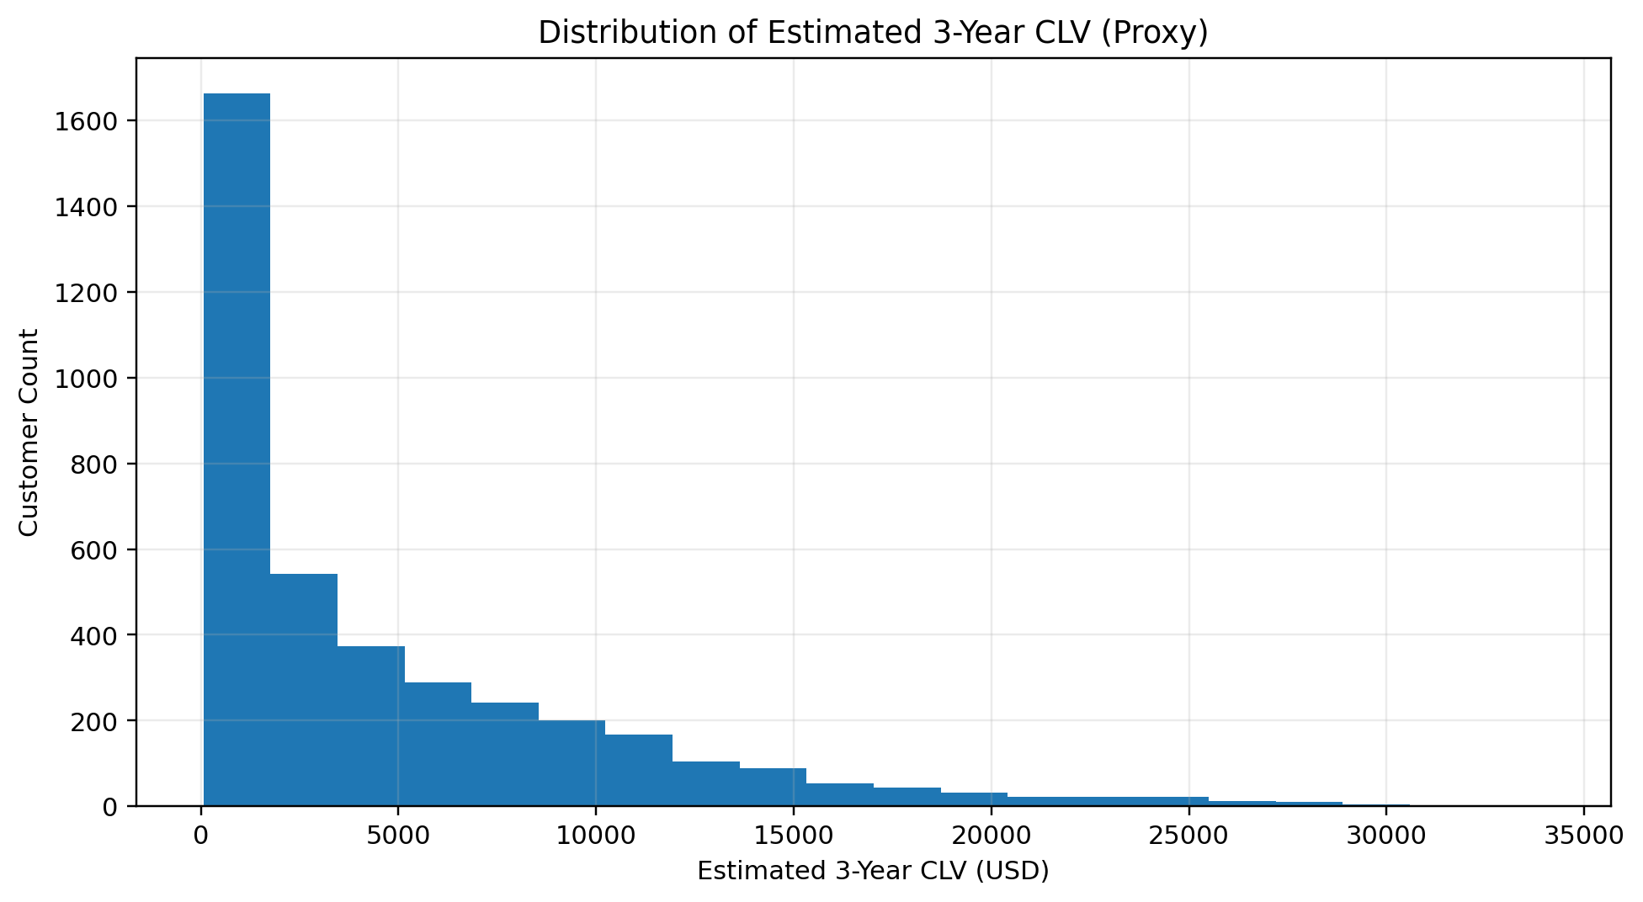
Observation: The CLV proxy is right-skewed, which means a smaller set of customers contributes a disproportionately large share of projected value.
Appendix D : Frequency and Segment Support
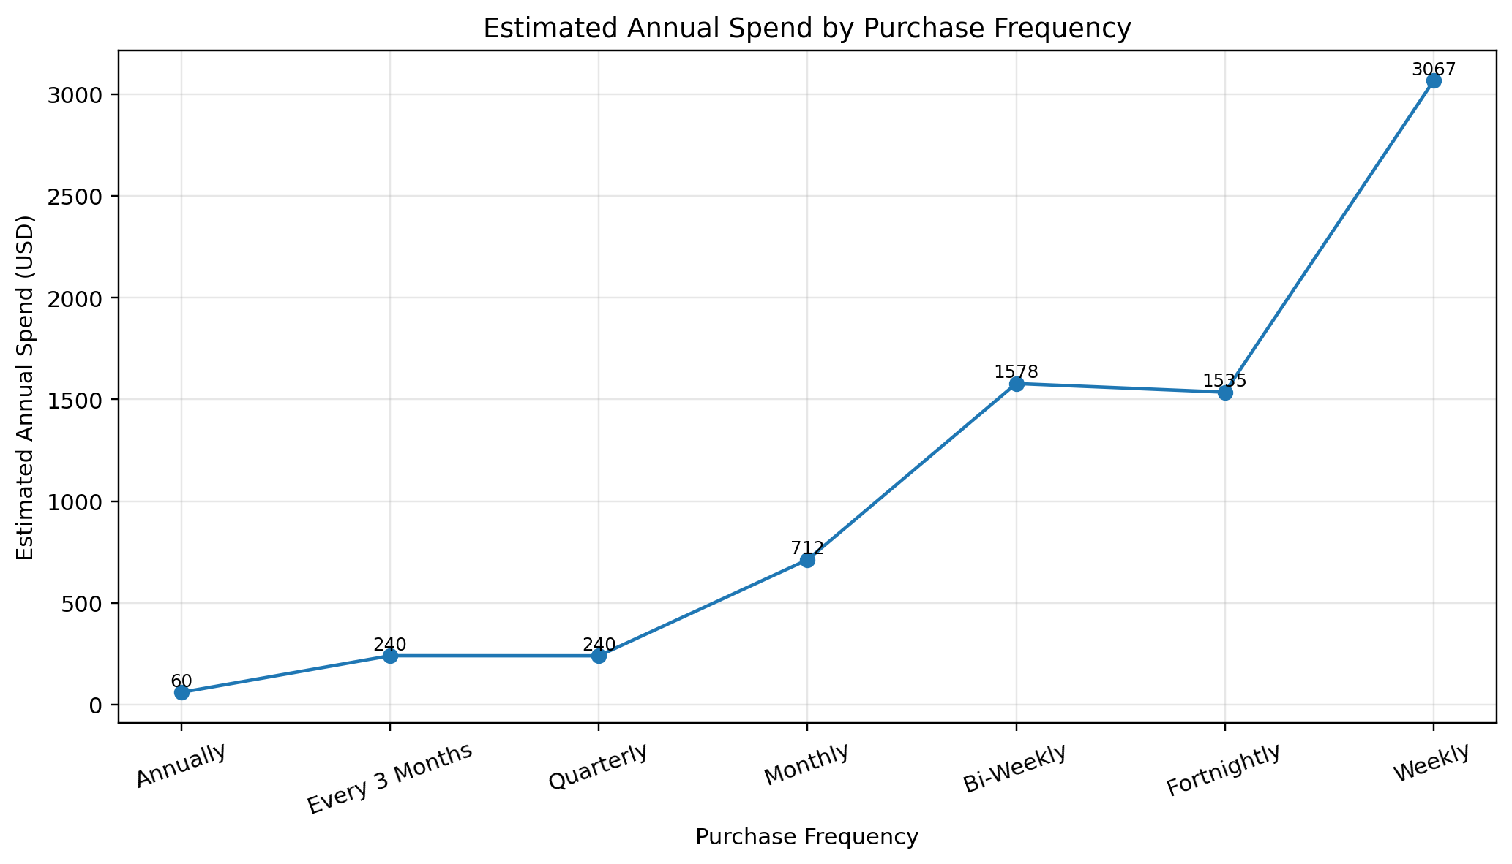
Observation: Frequency amplifies value quickly. Even when individual purchase amounts are moderate, repeated buying lifts the annualized value sharply.
Observation: The four segments are fairly balanced in count, which makes the segmentation useful for explaining differentiated business actions.

